**CHAPTER-1**

An introduction to Machine Learning-

The term Machine Learning was coined by Arthur Samuel in 1959, an American pioneer in the field of computer gaming and artificial intelligence and stated that “it gives computers the ability to learn without being explicitly programmed”.  
And in 1997, Tom Mitchell gave a “well-posed” mathematical and relational definition that “A computer program is said to learn from experience E with respect to some task T and some performance measure P, if its performance on T, as measured by P, improves with experience E.

Machine Learning is a latest buzzword floating around. It deserves to, as it is one of the most interesting subfield of Computer Science. So what does Machine Learning really mean?

Let’s try to understand Machine Learning in layman terms. Consider you are trying to toss a paper to a dustbin.

After first attempt, you realize that you have put too much force in it. After second attempt, you realize you are closer to target but you need to increase your throw angle. What is happening here is basically after every throw we are learning something and improving the end result. We are programmed to learn from our experience.

This implies that the tasks in which machine learning is concerned offers a fundamentally operational definition rather than defining the field in cognitive terms. This follows Alan Turing’s proposal in his paper “Computing Machinery and Intelligence”, in which the question “Can machines think?” is replaced with the question “Can machines do what we (as thinking entities) can do?”  
Within the field of data analytics, machine learning is used to devise complex models and algorithms that lend themselves to prediction; in commercial use, this is known as predictive analytics. These analytical models allow researchers, data scientists, engineers, and analysts to “produce reliable, repeatable decisions and results” and uncover “hidden insights” through learning from historical relationships and trends in the data set(input).

Suppose that you decide to check out that offer for a vacation . You browse through the travel agency website and search for a hotel. When you look at a specific hotel, just below the hotel description there is a section titled “You might also like these hotels”. This is a common use case of Machine Learning called “Recommendation Engine”. Again, many data points were used to train a model in order to predict what will be the best hotels to show you under that section, based on a lot of information they already know about you.

So if you want your program to predict, for example, traffic patterns at a busy intersection (task T), you can run it through a machine learning algorithm with data about past traffic patterns (experience E) and, if it has successfully “learned”, it will then do better at predicting future traffic patterns (performance measure P).  
The highly complex nature of many real-world problems, though, often means that inventing specialized algorithms that will solve them perfectly every time is impractical, if not impossible. Examples of machine learning problems include, “Is this cancer?”, “Which of these people are good friends with each other?”, “Will this person like this movie?” such problems are excellent targets for Machine Learning, and in fact machine learning has been applied such problems with great success.

**Categorizing on the basis of required Output**

Another categorization of machine learning tasks arises when one considers the desired output of a machine-learned system:

1. **Classification :** When inputs are divided into two or more classes, and the learner must produce a model that assigns unseen inputs to one or more (multi-label classification) of these classes. This is typically tackled in a supervised way. Spam filtering is an example of classification, where the inputs are email (or other) messages and the classes are “spam” and “not spam”.
2. **Regression :** Which is also a supervised problem, A case when the outputs are continuous rather than discrete.
3. **Clustering :** When a set of inputs is to be divided into groups. Unlike in classification, the groups are not known beforehand, making this typically an unsupervised task.

# What is Machine Learning?

**Arthur Samuel**, a pioneer in the field of artificial intelligence and computer gaming, coined the term **“Machine Learning”**. He defined machine learning as – **“Field of study that gives computers the capability to learn without being explicitly programmed”**.  
In a very layman manner, Machine Learning(ML) can be explained as automating and improving the learning process of computers based on their experiences without being actually programmed i.e. without any human assistance. The process starts with feeding good quality data and then training our machines(computers) by building machine learning models using the data and different algorithms. The choice of algorithms depends on what type of data do we have and what kind of task we are trying to automate.

# Data in Machine Learning

**DATA :** It can be any unprocessed fact, value, text, sound or picture that is not being interpreted and analyzed. Data is the most important part of all Data Analytics, Machine Learning, Artificial Intelligence. Without data, we can’t train any model and all modern research and automation will go vain. Big Enterprises are spending lots of money just to gather as much certain data as possible.

**How we split data in Machine Learning?**

* **Training Data:**The part of data we use to train our model. This is the data which your model actually sees(both input and output) and learn from.
* **Validation Data:**The part of data which is used to do a frequent evaluation of model, fit on training dataset along with improving involved hyperparameters (initially set parameters before the model begins learning). This data plays it’s part when the model is actually training.
* **Testing Data:**Once our model is completely trained, testing data provides the unbiased evaluation. When we feed in the inputs of Testing data, our model will predict some values(without seeing actual output). After prediction, we evaluate our model by comparing it with actual output present in the testing data. This is how we evaluate and see how much our model has learned from the experiences feed in as training data, set at the time of training.

**CHAPTER-2**

# Best Python libraries for Machine Learning-

Machine Learning, as the name suggests, is the science of programming a computer by which they are able to learn from different kinds of data. A more general definition given by Arthur Samuel is – “Machine Learning is the field of study that gives computers the ability to learn without being explicitly programmed.” They are typically used to solve various types of life problems.  
In the older days, people used to perform Machine Learning tasks by manually coding all the algorithms and mathematical and statistical formula. This made the process time consuming, tedious and inefficient. But in the modern days, it is become very much easy and efficient compared to the olden days by various python libraries, frameworks, and modules. Today, Python is one of the most popular programming languages for this task and it has replaced many languages in the industry, one of the reason is its vast collection of libraries. Python libraries that used in Machine Learning are:

* Numpy
* Scipy
* Scikit-learn
* Theano
* TensorFlow
* Keras
* PyTorch
* Pandas
* Matplotlib

#### **Numpy**

#### NumPy is a very popular python library for large multi-dimensional array and matrix processing, with the help of a large collection of high-level mathematical functions. It is very useful for fundamental scientific computations in Machine Learning. It is particularly useful for linear algebra, Fourier transform, and random number capabilities. High-end libraries like TensorFlow uses NumPy internally for manipulation of Tensors.

#### **SciPy**

SciPy is a very popular library among Machine Learning enthusiasts as it contains different modules for optimization, linear algebra, integration and statistics. There is a difference between the SciPy library and the SciPy stack. The SciPy is one of the core packages that make up the SciPy stack. SciPy is also very useful for image manipulation.

#### **Scikit-learn**

#### Skikit-learn is one of the most popular ML libraries for classical ML algorithms. It is built on top of two basic Python libraries, viz., NumPy and SciPy. Scikit-learn supports most of the supervised and unsupervised learning algorithms. Scikit-learn can also be used for data-mining and data-analysis, which makes it a great tool who is starting out with ML.

#### **Theano**

We all know that Machine Learning is basically mathematics and statistics. Theano is a popular python library that is used to define, evaluate and optimize mathematical expressions involving multi-dimensional arrays in an efficient manner. It is achieved by optimizing the utilization of CPU and GPU. It is extensively used for unit-testing and self-verification to detect and diagnose different types of errors. Theano is a very powerful library that has been used in large-scale computationally intensive scientific projects for a long time but is simple and approachable enough to be used by individuals for their own projects.

#### **Tensor Flow**

TensorFlow is a very popular open-source library for high performance numerical computation developed by the Google Brain team in Google. As the name suggests, Tensorflow is a framework that involves defining and running computations involving tensors. It can train and run deep neural networks that can be used to develop several AI applications. TensorFlow is widely used in the field of deep learning research and application.

#### **Keras**

Keras is a very popular Machine Learning library for Python. It is a high-level neural networks API capable of running on top of TensorFlow, CNTK, or Theano. It can run seamlessly on both CPU and GPU. Keras makes it really for ML beginners to build and design a Neural Network. One of the best thing about Keras is that it allows for easy and fast prototyping.

#### **PyTorch**

PyTorch is a popular open-source Machine Learning library for Python based on Torch, which is an open-source Machine Learning library which is implemented in C with a wrapper in Lua. It has an extensive choice of tools and libraries that supports on Computer Vision, Natural Language Processing(NLP) and many more ML programs. It allows developers to perform computations on Tensors with GPU acceleration and also helps in creating computational graphs.

#### **Pandas**

Pandas is a popular Python library for data analysis. It is not directly related to Machine Learning. As we know that the dataset must be prepared before training. In this case, Pandas comes handy as it was developed specifically for data extraction and preparation. It provides high-level data structures and wide variety tools for data analysis. It provides many inbuilt methods for groping, combining and filtering data.

#### **Matplotlib**

Matpoltlib is a very popular Python library for data visualization. Like Pandas, it is not directly related to Machine Learning. It particularly comes in handy when a programmer wants to visualize the patterns in the data. It is a 2D plotting library used for creating 2D graphs and plots. A module named pyplot makes it easy for programmers for plotting as it provides features to control line styles, font properties, formatting axes, etc. It provides various kinds of graphs and plots for data visualization, viz., histogram, error charts, bar chats, etc,

**CHAPTER-3**

Classification of Machine Learning-

Machine learning implementations are classified into three major categories, depending on the nature of the learning “signal” or “response” available to a learning system which are as follows:

Supervised and Unsupervised learning

**Supervised learning**

Supervised learning as the name indicates the presence of a supervisor as a teacher. Basically supervised learning is a learning in which we teach or train the machine using data which is well labeled that means some data is already tagged with the correct answer. After that, the machine is provided with a new set of examples(data) so that supervised learning algorithm analyses the training data(set of training examples) and produces a correct outcome from labeled data.

**Unsupervised learning**

Unsupervised learning is the training of machine using information that is neither classified nor labeled and allowing the algorithm to act on that information without guidance. Here the task of machine is to group unsorted information according to similarities, patterns and differences without any prior training of data.

Unlike supervised learning, no teacher is provided that means no training will be given to the machine. Therefore machine is restricted to find the hidden structure in unlabeled data by our-self.

### Hybrid Machine learning

Most of us have probably been using HML algorithms in one form or another without realizing it. We might have used methods that are a combination of existing ones or combined with methods that are imported from other fields. We sometimes apply data transformation methods such as principal component analysis (PCA) or simple linear correlation analysis on our data before passing them to an ML method. Some practitioners use evolutionary algorithms to automate the optimization of the parameters of existing ML methods. HML algorithms are based on an ML architecture that is slightly different from the conventional work flow. We seem to have taken the ML algorithms for granted as we simply use them off the shelf, usually without considering the details of how things fit together.

HML is an advancement of the ML work flow that seamlessly combines different algorithms, processes, or procedures from similar or different domains of knowledge or areas of application with the objective of complementing each other. As no single cap fits all heads, no single ML method is applicable to all problems. Some methods are good in handling noisy data but may not be capable of handling high-dimensional input space. Some others may scale pretty well on high-dimensional input space but may not be capable of handling sparse data. These conditions are a good premise to apply HML to complement the candidate methods and use one to overcome the weakness of the others. **Fig. 2**shows a conceptual framework of the HML work flow.

The possibilities for the hybridization of traditional ML methods are endless, and this can be done for every single one to build new hybrid models in different ways. For simplicity, this article will discuss three of them: architectural integration, data manipulation, and model parameters optimization.

[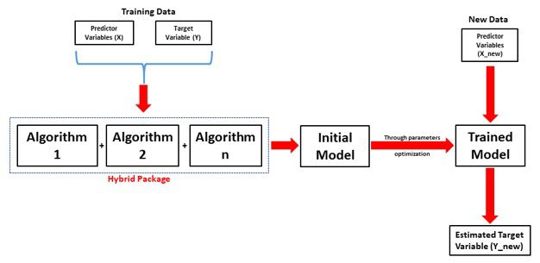](https://pubs.spe.org/media/filer_public/57/fa/57fa9fe0-3292-40e6-a752-58eeb18465e9/hybrid_fig2.jpg)**Fig. 3.1:**The HML (Hybrid Machine Learning) work flow.

Reinforcement learning

Reinforcement learning is an area of Machine Learning. It is about taking suitable action to maximize reward in a particular situation. It is employed by various software and machines to find the best possible behavior or path it should take in a specific situation. Reinforcement learning differs from the supervised learning in a way that in supervised learning the training data has the answer key with it so the model is trained with the correct answer itself whereas in reinforcement learning, there is no answer but the reinforcement agent decides what to do to perform the given task. In the absence of a training dataset, it is bound to learn from its experience.

**Table3.1: Difference between Reinforcement learning and Supervised learning:**

| **REINFORCEMENT LEARNING** | **SUPERVISED LEARNING** |
| --- | --- |
| Reinforcement learning is all about making decisions sequentially. In simple words we can say that the output depends on the state of the current input and the next input depends on the output of the previous input | In Supervised learning the decision is made on the initial input or the input given at the start |
| In Reinforcement learning decision is dependent, So we give labels to sequences of dependent decisions | Supervised learning the decisions are independent of each other so labels are given to each decision. |
| Example: Chess game | Example: Object recognition |

**Types of Reinforcement:** There are two types of Reinforcement:

1. **Positive –**  
   Positive Reinforcement is defined as when an event, occurs due to a particular behavior, increases the strength and the frequency of the behavior. In other words, it has a positive effect on behavior.

Advantages of reinforcement learning are:

* + Maximizes Performance
  + Sustain Change for a long period of time

Disadvantages of reinforcement learning:

* + Too much Reinforcement can lead to overload of states which can diminish the results

1. **Negative –**  
   Negative Reinforcement is defined as strengthening of a behavior because a negative condition is stopped or avoided.

Advantages of reinforcement learning:

* + Increases Behavior
  + Provide defiance to minimum standard of performance

Disadvantages of reinforcement learning:

* + It Only provides enough to meet up the minimum behavior

**Various Practical applications of Reinforcement Learning –**

* RL can be used in robotics for industrial automation.
* RL can be used in machine learning and data processing
* RL can be used to create training systems that provide custom instruction and materials according to the requirement of students.

**CHAPTER-4**

# Regression Analysis in Machine learning-

Regression analysis is a statistical method to model the relationship between a dependent (target) and independent (predictor) variables with one or more independent variables. More specifically, Regression analysis helps us to understand how the value of the dependent variable is changing corresponding to an independent variable when other independent variables are held fixed. It predicts continuous/real values such as **temperature, age, salary, price,** etc.

Regression is a [supervised learning technique](https://www.javatpoint.com/supervised-machine-learning) which helps in finding the correlation between variables and enables us to predict the continuous output variable based on the one or more predictor variables. It is mainly used for **prediction, forecasting, time series modeling, and determining the causal-effect relationship between variables**.

In Regression, we plot a graph between the variables which best fits the given datapoints, using this plot, the machine learning model can make predictions about the data. In simple words, ***"Regression shows a line or curve that passes through all the datapoints on target-predictor graph in such a way that the vertical distance between the datapoints and the regression line is minimum."*** The distance between datapoints and line tells whether a model has captured a strong relationship or not.

Some examples of regression can be as:

* Prediction of rain using temperature and other factors
* Determining Market trends
* Prediction of road accidents due to rash driving.

## Terminologies Related to the Regression Analysis:

* **Dependent Variable:** The main factor in Regression analysis which we want to predict or understand is called the dependent variable. It is also called **target variable**.
* **Independent Variable:** The factors which affect the dependent variables or which are used to predict the values of the dependent variables are called independent variable, also called as a **predictor**.
* **Outliers:** Outlier is an observation which contains either very low value or very high value in comparison to other observed values. An outlier may hamper the result, so it should be avoided.
* **Multicollinearity:** If the independent variables are highly correlated with each other than other variables, then such condition is called Multicollinearity. It should not be present in the dataset, because it creates problem while ranking the most affecting variable.
* **Underfitting and Overfitting:** If our algorithm works well with the training dataset but not well with test dataset, then such problem is called **Overfitting**. And if our algorithm does not perform well even with training dataset, then such problem is called **underfitting**.

## Why do we use Regression Analysis?

As mentioned above, Regression analysis helps in the prediction of a continuous variable. There are various scenarios in the real world where we need some future predictions such as weather condition, sales prediction, marketing trends, etc., for such case we need some technology which can make predictions more accurately. So for such case we need Regression analysis which is a statistical method and used in machine learning and data science. Below are some other reasons for using Regression analysis:

* Regression estimates the relationship between the target and the independent variable.
* It is used to find the trends in data.
* It helps to predict real/continuous values.
* By performing the regression, we can confidently determine the **most important factor, the least important factor, and how each factor is affecting the other factors**.

## Types of Regression

There are various types of regressions which are used in data science and machine learning. Each type has its own importance on different scenarios, but at the core, all the regression methods analyze the effect of the independent variable on dependent variables. Here we are discussing some important types of regression which are given below:

* **Linear Regression**
* **Logistic Regression**
* **Polynomial Regression**
* **Support Vector Regression**
* **Decision Tree Regression**
* **Random Forest Regression**
* **Ridge Regression**
* **Lasso Regression:**

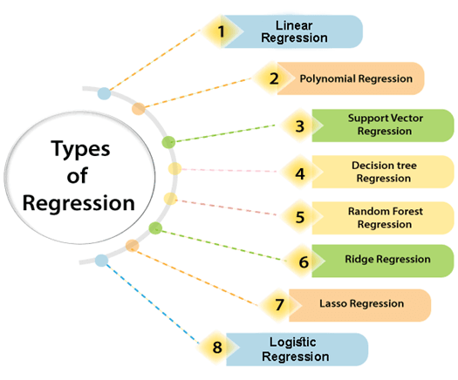

**Fig. 4.1: Types of Regression.**

### Linear Regression:

* Linear regression is a statistical regression method which is used for predictive analysis.
* It is one of the very simple and easy algorithms which works on regression and shows the relationship between the continuous variables.
* It is used for solving the regression problem in machine learning.
* Linear regression shows the linear relationship between the independent variable (X-axis) and the dependent variable (Y-axis), hence called linear regression.
* If there is only one input variable (x), then such linear regression is called **simple linear regression**. And if there is more than one input variable, then such linear regression is called **multiple linear regression**.
* The relationship between variables in the linear regression model can be explained using the below image. Here we are predicting the salary of an employee on the basis of **the year of experience**.

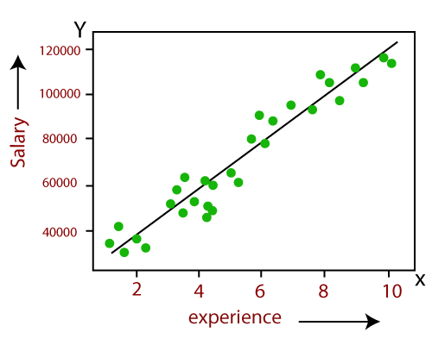

**Fig. 4.2: Linear Relationship between two variables.**

* Below is the mathematical equation for Linear regression:

1. Y= aX+b

**Here, Y = dependent variables (target variables),**  
**X= Independent variables (predictor variables),**  
**a and b are the linear coefficients**

Some popular applications of linear regression are:

* **Analyzing trends and sales estimates**
* **Salary forecasting**
* **Real estate prediction**
* **Arriving at ETAs in traffic.**

### Logistic Regression:

* Logistic regression is another supervised learning algorithm which is used to solve the classification problems. In **classification problems**, we have dependent variables in a binary or discrete format such as 0 or 1.
* Logistic regression algorithm works with the categorical variable such as 0 or 1, Yes or No, True or False, Spam or not spam, etc.
* It is a predictive analysis algorithm which works on the concept of probability.
* Logistic regression is a type of regression, but it is different from the linear regression algorithm in the term how they are used.
* Logistic regression uses **sigmoid function** or logistic function which is a complex cost function. This sigmoid function is used to model the data in logistic regression. The function can be represented as:

Regression Analysis in Machine learning

* f(x)= Output between the 0 and 1 value.
* x= input to the function
* e= base of natural logarithm.

When we provide the input values (data) to the function, it gives the S-curve as follows:

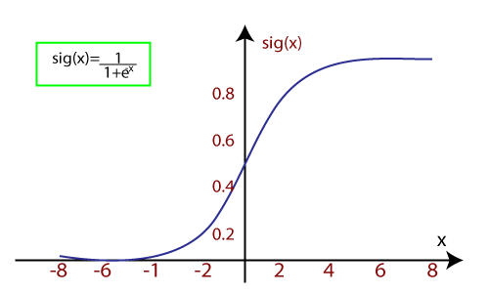

**Fig. 4.3: Sigmoid function curve.**

* It uses the concept of threshold levels, values above the threshold level are rounded up to 1, and values below the threshold level are rounded up to 0.

There are three types of logistic regression:

* **Binary(0/1, pass/fail)**
* **Multi(cats, dogs, lions)**
* **Ordinal(low, medium, high)**

### Polynomial Regression:

* Polynomial Regression is a type of regression which models the **non-linear dataset** using a linear model.
* It is similar to multiple linear regression, but it fits a non-linear curve between the value of x and corresponding conditional values of y.
* Suppose there is a dataset which consists of datapoints which are present in a non-linear fashion, so for such case, linear regression will not best fit to those datapoints. To cover such datapoints, we need Polynomial regression.
* I**n Polynomial regression, the original features are transformed into polynomial features of given degree and then modeled using a linear model.** Which means the datapoints are best fitted using a polynomial line.

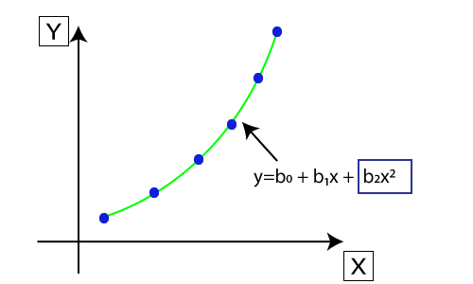

**Fig. 4.4: Polynomial Regression datapoints.**

* The equation for polynomial regression also derived from linear regression equation that means Linear regression equation Y= b0+ b1x, is transformed into Polynomial regression equation Y= b0+b1x+ b2x2+ b3x3+.....+ bnxn.
* Here Y is the **predicted/target output, b0, b1,... bn are the regression coefficients**. x is our **independent/input variable**.
* The model is still linear as the coefficients are still linear with quadratic

### Support Vector Regression:

Support Vector Machine is a supervised learning algorithm which can be used for regression as well as classification problems. So if we use it for regression problems, then it is termed as Support Vector Regression.

Support Vector Regression is a regression algorithm which works for continuous variables. Below are some keywords which are used in **Support Vector Regression**:

* **Kernel:** It is a function used to map a lower-dimensional data into higher dimensional data.
* **Hyperplane:** In general SVM, it is a separation line between two classes, but in SVR, it is a line which helps to predict the continuous variables and cover most of the datapoints.
* **Boundary line:** Boundary lines are the two lines apart from hyperplane, which creates a margin for datapoints.
* **Support vectors:** Support vectors are the datapoints which are nearest to the hyperplane and opposite class.

In SVR, we always try to determine a hyperplane with a maximum margin, so that maximum number of datapoints are covered in that margin. **The main goal of SVR is to consider the maximum datapoints within the boundary lines and the hyperplane (best-fit line) must contain a maximum number of datapoints**. Consider the below image:

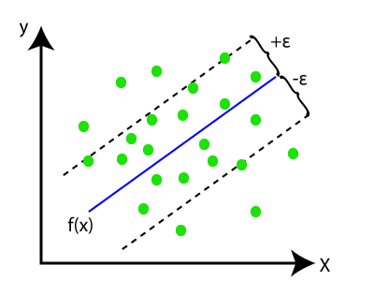

**Fig. 4.5: Support vector data points.**

Here, the blue line is called hyperplane, and the other two lines are known as boundary lines

**CHAPTER-5**

Decision Tree Regression-

* Decision tree algorithm falls under the category of supervised learning. They can be used to solve both regression and classification problems.
* Decision tree uses the tree representation to solve the problem in which each leaf node corresponds to a class label and attributes are represented on the internal node of the tree.
* We can represent any boolean function on discrete attributes using the decision tree.

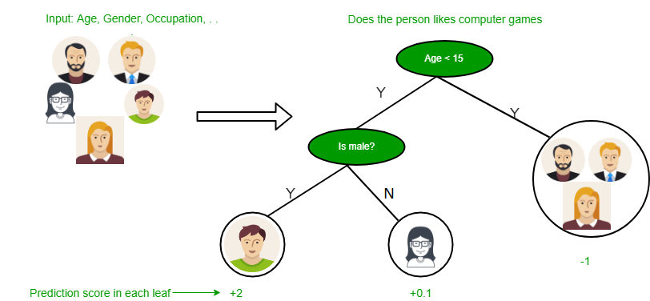

**Fig. 5.1—**Decision Tree.

Below are some assumptions that we made while using decision tree:

* At the beginning, we consider the whole training set as the root.
* Feature values are preferred to be categorical. If the values are continuous then they are discretized prior to building the model.
* On the basis of attribute values records are distributed recursively.
* We use statistical methods for ordering attributes as root or the internal node.

**Fig. 5.2—**Decision Tree example.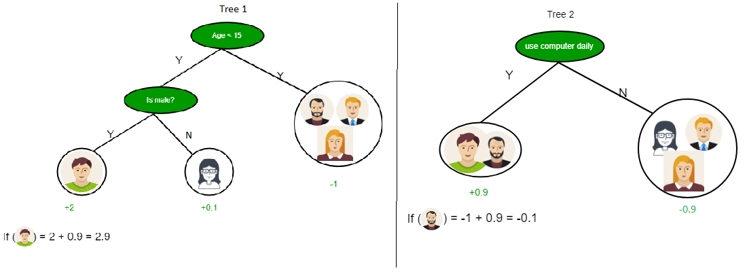

As you can see from the above image that Decision Tree works on the Sum of Product form which is also known as *Disjunctive Normal Form*. In the above image, we are predicting the use of computer in the daily life of the people.

In Decision Tree the major challenge is to identification of the attribute for the root node in each level. This process is known as attribute selection.

**CHAPTER-6**

# Random Forest Regression-

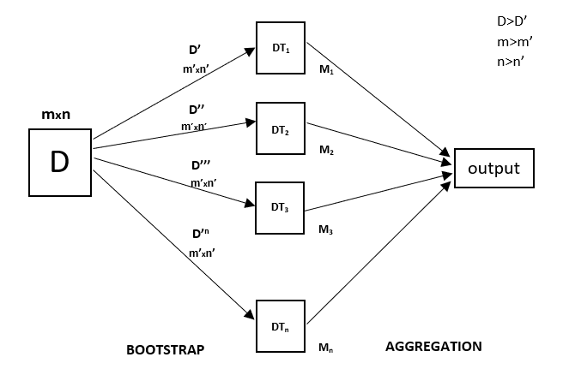Every decision tree has high variance, but when we combine all of them together in parallel then the resultant variance is low as each decision tree gets perfectly trained on that particular sample data and hence the output doesn’t depend on one decision tree but multiple decision trees. In the case of a classification problem, the final output is taken by using the majority voting classifier. In the case of a regression problem, the final output is the mean of all the outputs. This part is Aggregation.

**Fig. 6.1—**Random Forest Prediction.

A Random Forest is an ensemble technique capable of performing both regression and classification tasks with the use of multiple decision trees and a technique called Bootstrap and Aggregation, commonly known as **bagging**. The basic idea behind this is to combine multiple decision trees in determining the final output rather than relying on individual decision trees.  
Random Forest has multiple decision trees as base learning models. We randomly perform row sampling and feature sampling from the dataset forming sample datasets for every model. This part is called Bootstrap.

We need to approach the Random Forest regression technique like any other machine learning technique

* Design a specific question or data and get the source to determine the required data.
* Make sure the data is in an accessible format else convert it to the required format.
* Specify all noticeable anomalies and missing data points that may be required to achieve the required data.
* Create a machine learning model
* Set the baseline model that you want to achieve
* Train the data machine learning model.
* Provide an insight into the model with test data
* Now compare the performance metrics of both the test data and the predicted data from the model.
* If it doesn’t satisfy your expectations, you can try improving your model accordingly or dating your data or use another data modeling technique.
* At this stage you interpret the data you have gained and report accordingly.

Advantages of Random Forests

Random forests present estimates for variable importance, i.e., neural nets. They also offer a superior method for working with missing data. Missing values are substituted by the variable appearing the most in a particular node. Among all the available classification methods, random forests provide the highest accuracy.

The random forest technique can also handle big data with numerous variables running into thousands. It can automatically balance data sets when a class is more infrequent than other classes in the data. The method also handles variables fast, making it suitable for complicated tasks.

**CHAPTER-7**

# Linear Regression in Machine Learning-

Linear regression is one of the easiest and most popular Machine Learning algorithms. It is a statistical method that is used for predictive analysis. Linear regression makes predictions for continuous/real or numeric variables such as **sales, salary, age, product price,** etc.

Linear regression algorithm shows a linear relationship between a dependent (y) and one or more independent (y) variables, hence called as linear regression. Since linear regression shows the linear relationship, which means it finds how the value of the dependent variable is changing according to the value of the independent variable.

The linear regression model provides a sloped straight line representing the relationship between the variables. Consider the below image:

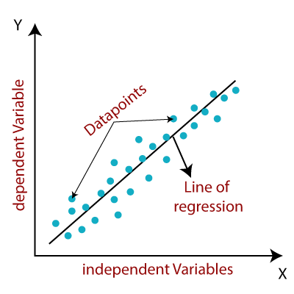

**Fig. 7.1: Linear Regression relationship between variables.**

Mathematically, we can represent a linear regression as:

y= a0+a1x+ ε

**Here,**

Y= Dependent Variable (Target Variable)  
X= Independent Variable (predictor Variable)  
a0= intercept of the line (Gives an additional degree of freedom)  
a1 = Linear regression coefficient (scale factor to each input value).  
ε = random error

The values for x and y variables are training datasets for Linear Regression model representation.

## Types of Linear Regression

Linear regression can be further divided into two types of the algorithm:

* **Simple Linear Regression:**  
  If a single independent variable is used to predict the value of a numerical dependent variable, then such a Linear Regression algorithm is called Simple Linear Regression.
* **Multiple Linear regression:**  
  If more than one independent variable is used to predict the value of a numerical dependent variable, then such a Linear Regression algorithm is called Multiple Linear Regression.

## Linear Regression Line

A linear line showing the relationship between the dependent and independent variables is called a **regression line**. A regression line can show two types of relationship:

* **Positive Linear Relationship:**  
  If the dependent variable increases on the Y-axis and independent variable increases on X-axis, then such a relationship is termed as a Positive linear relationship.

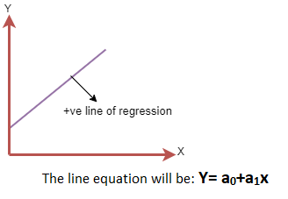

**Fig. 7.2: Positive linear Relationship.**

* **Negative Linear Relationship:**  
  If the dependent variable decreases on the Y-axis and independent variable increases on the X-axis, then such a relationship is called a negative linear relationship.

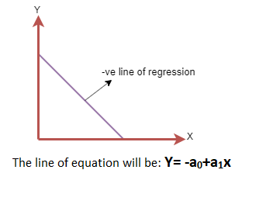

**Fig. 7.3: Negative Linear Relationship.**

## Finding the best fit line:

When working with linear regression, our main goal is to find the best fit line that means the error between predicted values and actual values should be minimized. The best fit line will have the least error.

The different values for weights or the coefficient of lines (a0, a1) gives a different line of regression, so we need to calculate the best values for a0 and a1 to find the best fit line, so to calculate this we use cost function.

### Cost function:

* The different values for weights or coefficient of lines (a0, a1) gives the different line of regression, and the cost function is used to estimate the values of the coefficient for the best fit line.
* Cost function optimizes the regression coefficients or weights. It measures how a linear regression model is performing.
* We can use the cost function to find the accuracy of the **mapping function**, which maps the input variable to the output variable. This mapping function is also known as **Hypothesis function**.

For Linear Regression, we use the **Mean Squared Error (MSE)** cost function, which is the average of squared error occurred between the predicted values and actual values. It can be written as:

For the above linear equation, MSE can be calculated as:

Linear Regression in Machine Learning

**Where,**

N=Total number of observation  
Yi = Actual value  
(a1xi+a0)= Predicted value.

**Residuals:** The distance between the actual value and predicted values is called residual. If the observed points are far from the regression line, then the residual will be high, and so cost function will high. If the scatter points are close to the regression line, then the residual will be small and hence the cost function.

### Gradient Descent:

* Gradient descent is used to minimize the MSE by calculating the gradient of the cost function.
* A regression model uses gradient descent to update the coefficients of the line by reducing the cost function.
* It is done by a random selection of values of coefficient and then iteratively update the values to reach the minimum cost function.

## Model Performance:

The Goodness of fit determines how the line of regression fits the set of observations. The process of finding the best model out of various models is called **optimization**. It can be achieved by below method:

**1. R-squared method:**

* R-squared is a statistical method that determines the goodness of fit.
* It measures the strength of the relationship between the dependent and independent variables on a scale of 0-100%.
* The high value of R-square determines the less difference between the predicted values and actual values and hence represents a good model.
* It is also called a **coefficient of determination,** or **coefficient of multiple determination** for multiple regression.
* It can be calculated from the below formula:

Linear Regression in Machine Learning

## Assumptions of Linear Regression

Below are some important assumptions of Linear Regression. These are some formal checks while building a Linear Regression model, which ensures to get the best possible result from the given dataset.

* **Linear relationship between the features and target:**  
  Linear regression assumes the linear relationship between the dependent and independent variables.
* **Small or no multicollinearity between the features:**  
  Multicollinearity means high-correlation between the independent variables. Due to multicollinearity, it may difficult to find the true relationship between the predictors and target variables. Or we can say, it is difficult to determine which predictor variable is affecting the target variable and which is not. So, the model assumes either little or no multicollinearity between the features or independent variables.
* **Homoscedasticity Assumption:**  
  Homoscedasticity is a situation when the error term is the same for all the values of independent variables. With homoscedasticity, there should be no clear pattern distribution of data in the scatter plot.
* **Normal distribution of error terms:**  
  Linear regression assumes that the error term should follow the normal distribution pattern. If error terms are not normally distributed, then confidence intervals will become either too wide or too narrow, which may cause difficulties in finding coefficients.  
  It can be checked using the **q-q plot**. If the plot shows a straight line without any deviation, which means the error is normally distributed.
* **No autocorrelations:**  
  The linear regression model assumes no autocorrelation in error terms. If there will be any correlation in the error term, then it will drastically reduce the accuracy of the model. Autocorrelation usually occurs if there is a dependency between residual errors.

**CHAPTER-8**

# Classification Algorithm in Machine Learning-

As we know, the Supervised Machine Learning algorithm can be broadly classified into Regression and Classification Algorithms. In Regression algorithms, we have predicted the output for continuous values, but to predict the categorical values, we need Classification algorithms.

## What is the Classification Algorithm?

The Classification algorithm is a Supervised Learning technique that is used to identify the category of new observations on the basis of training data. In Classification, a program learns from the given dataset or observations and then classifies new observation into a number of classes or groups. Such as, **Yes or No, 0 or 1, Spam or Not Spam, cat or dog,** etc. Classes can be called as targets/labels or categories.

Unlike regression, the output variable of Classification is a category, not a value, such as "Green or Blue", "fruit or animal", etc. Since the Classification algorithm is a Supervised learning technique, hence it takes labeled input data, which means it contains input with the corresponding output.

In classification algorithm, a discrete output function(y) is mapped to input variable(x).

1. y=f(x), where y = categorical output

The best example of an ML classification algorithm is **Email Spam Detector**.

The main goal of the Classification algorithm is to identify the category of a given dataset, and these algorithms are mainly used to predict the output for the categorical data.

Classification algorithms can be better understood using the below diagram. In the below diagram, there are two classes, class A and Class B. These classes have features that are similar to each other and dissimilar to other classes.

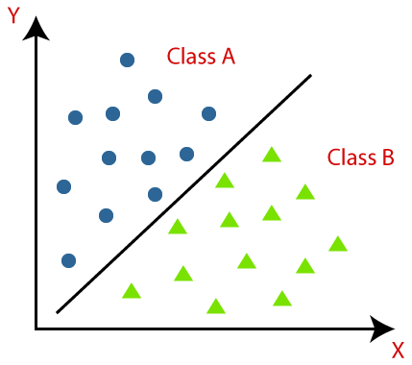

**Fig. 8.1: Classification Algorithm graph of example.**

The algorithm which implements the classification on a dataset is known as a classifier. There are two types of Classifications:

* **Binary Classifier:** If the classification problem has only two possible outcomes, then it is called as Binary Classifier.  
  **Examples:** YES or NO, MALE or FEMALE, SPAM or NOT SPAM, CAT or DOG, etc.
* **Multi-class Classifier:** If a classification problem has more than two outcomes, then it is called as Multi-class Classifier.  
  **Example:** Classifications of types of crops, Classification of types of music.

## Learners in Classification Problems:

In the classification problems, there are two types of learners:

1. **Lazy Learners:** Lazy Learner firstly stores the training dataset and wait until it receives the test dataset. In Lazy learner case, classification is done on the basis of the most related data stored in the training dataset. It takes less time in training but more time for predictions.  
   **Example:** K-NN algorithm, Case-based reasoning
2. **Eager Learners:** Eager Learners develop a classification model based on a training dataset before receiving a test dataset. Opposite to Lazy learners, Eager learners take less time in training and more time in prediction. **Example:** Decision Trees, Naïve Bayes, ANN.

## Types of ML Classification Algorithms:

Classification Algorithms can be further divided into the Mainly two category:

* **Linear Models**
  + Logistic Regression
  + Support Vector Machines
* **Non-linear Models**
  + K-Nearest Neighbours
  + Kernel SVM
  + Naïve Bayes
  + Decision Tree Classification
  + Random Forest Classification

## Evaluating a Classification model:

Once our model is completed, it is necessary to evaluate its performance; either it is a Classification or Regression model. So for evaluating a Classification model, we have the following ways:

**1. Log Loss or Cross-Entropy Loss:**

* It is used for evaluating the performance of a classifier, whose output is a probability value between the 0 and 1.
* For a good binary Classification model, the value of log loss should be near to 0.
* The value of log loss increases if the predicted value deviates from the actual value.
* The lower log loss represents the higher accuracy of the model.
* For Binary classification, cross-entropy can be calculated as:

?(ylog(p)+(1?y)log(1?p))

Where y= Actual output, p= predicted output.

**2. Confusion Matrix:**

* The confusion matrix provides us a matrix/table as output and describes the performance of the model.
* It is also known as the error matrix.
* The matrix consists of predictions result in a summarized form, which has a total number of correct predictions and incorrect predictions. The matrix looks like as below table:

**Table.8.1:** Prediction of Confusion Matrix.

|  |  |  |
| --- | --- | --- |
|  | **Actual Positive** | **Actual Negative** |
| Predicted Positive | True Positive | False Positive |
| Predicted Negative | False Negative | True Negative |

Classification Algorithm in Machine Learning

**3. AUC-ROC curve:**

* ROC curve stands for **Receiver Operating Characteristics Curve** and AUC stands for **Area Under the Curve**.
* It is a graph that shows the performance of the classification model at different thresholds.
* To visualize the performance of the multi-class classification model, we use the AUC-ROC Curve.
* The ROC curve is plotted with TPR and FPR, where TPR (True Positive Rate) on Y-axis and FPR(False Positive Rate) on X-axis.

## Use cases of Classification Algorithms

Classification algorithms can be used in different places. Below are some popular use cases of Classification Algorithms:

* Email Spam Detection
* Speech Recognition
* Identifications of Cancer tumor cells.
* Drugs Classification
* Biometric Identification, etc.

**CHAPTER-9**

# Logistic Regression in Machine Learning-

* Logistic regression is one of the most popular Machine Learning algorithms, which comes under the Supervised Learning technique. It is used for predicting the categorical dependent variable using a given set of independent variables.
* Logistic regression predicts the output of a categorical dependent variable. Therefore the outcome must be a categorical or discrete value. It can be either Yes or No, 0 or 1, true or False, etc. but instead of giving the exact value as 0 and 1, **it gives the probabilistic values which lie between 0 and 1**.
* Logistic Regression is much similar to the Linear Regression except that how they are used. Linear Regression is used for solving Regression problems, whereas **Logistic regression is used for solving the classification problems**.
* In Logistic regression, instead of fitting a regression line, we fit an "S" shaped logistic function, which predicts two maximum values (0 or 1).
* The curve from the logistic function indicates the likelihood of something such as whether the cells are cancerous or not, a mouse is obese or not based on its weight, etc.
* Logistic Regression is a significant machine learning algorithm because it has the ability to provide probabilities and classify new data using continuous and discrete datasets.
* Logistic Regression can be used to classify the observations using different types of data and can easily determine the most effective variables used for the classification. The below image is showing the logistic function:

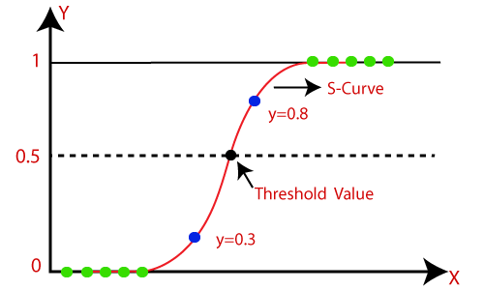

**Fig. 9.1: Logistic Linear Function.**

## Logistic Function (Sigmoid Function):

* The sigmoid function is a mathematical function used to map the predicted values to probabilities.
* It maps any real value into another value within a range of 0 and 1.
* The value of the logistic regression must be between 0 and 1, which cannot go beyond this limit, so it forms a curve like the "S" form. The S-form curve is called the Sigmoid function or the logistic function.
* In logistic regression, we use the concept of the threshold value, which defines the probability of either 0 or 1. Such as values above the threshold value tends to 1, and a value below the threshold values tends to 0.

## Assumptions for Logistic Regression:

* The dependent variable must be categorical in nature.
* The independent variable should not have multi-collinearity.

## Logistic Regression Equation:

The Logistic regression equation can be obtained from the Linear Regression equation. The mathematical steps to get Logistic Regression equations are given below:

* We know the equation of the straight line can be written as:

Logistic Regression in Machine Learning

* In Logistic Regression y can be between 0 and 1 only, so for this let's divide the above equation by (1-y):

Logistic Regression in Machine Learning

* But we need range between -[infinity] to +[infinity], then take logarithm of the equation it will become:

Logistic Regression in Machine Learning

The above equation is the final equation for Logistic Regression.

**CHAPTER-10**

K-Nearest Neighbor (KNN) Algorithm-

K-Nearest Neighbour is one of the simplest Machine Learning algorithms based on Supervised Learning technique.

* K-NN algorithm assumes the similarity between the new case/data and available cases and put the new case into the category that is most similar to the available categories.
* K-NN algorithm stores all the available data and classifies a new data point based on the similarity. This means when new data appears then it can be easily classified into a well suite category by using K- NN algorithm.
* K-NN algorithm can be used for Regression as well as for Classification but mostly it is used for the Classification problems.
* K-NN is a **non-parametric algorithm**, which means it does not make any assumption on underlying data.
* It is also called a **lazy learner algorithm** because it does not learn from the training set immediately instead it stores the dataset and at the time of classification, it performs an action on the dataset.
* KNN algorithm at the training phase just stores the dataset and when it gets new data, then it classifies that data into a category that is much similar to the new data.
* **Example:** Suppose, we have an image of a creature that looks similar to cat and dog, but we want to know either it is a cat or dog. So for this identification, we can use the KNN algorithm, as it works on a similarity measure. Our KNN model will find the similar features of the new data set to the cats and dogs images and based on the most similar features it will put it in either cat or dog category.

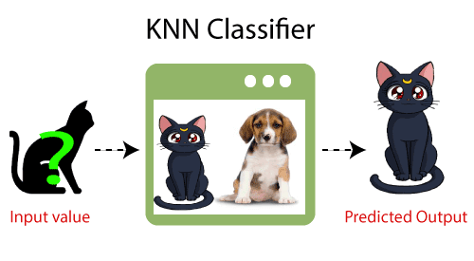

**Fig. 10.1: K-NN Classifier.**

## Why do we need a K-NN Algorithm?

Suppose there are two categories, i.e., Category A and Category B, and we have a new data point x1, so this data point will lie in which of these categories. To solve this type of problem, we need a K-NN algorithm. With the help of K-NN, we can easily identify the category or class of a particular dataset. Consider the below diagram:

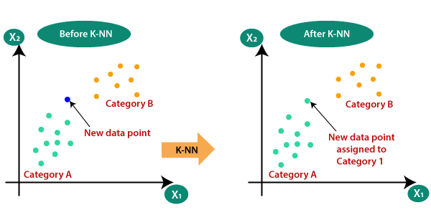

**Fig. 10.2: Need of K-NN.**

## How does K-NN work?

The K-NN working can be explained on the basis of the below algorithm:

* **Step-1:** Select the number K of the neighbors
* **Step-2:** Calculate the Euclidean distance of **K number of neighbors**
* **Step-3:** Take the K nearest neighbors as per the calculated Euclidean distance.
* **Step-4:** Among these k neighbors, count the number of the data points in each category.
* **Step-5:** Assign the new data points to that category for which the number of the neighbor is maximum.
* **Step-6:** Our model is ready.

Suppose we have a new data point and we need to put it in the required category. Consider the below image:

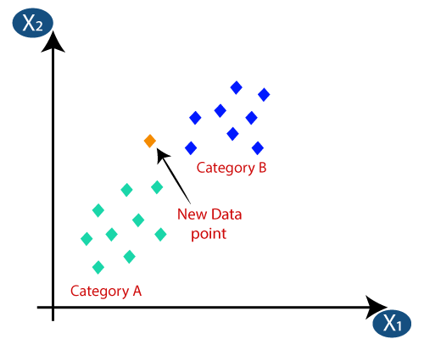

**Fig. 10.3: How to put new data points in K-NN.**

* Firstly, we will choose the number of neighbors, so we will choose the k=5.
* Next, we will calculate the **Euclidean distance** between the data points. The Euclidean distance is the distance between two points, which we have already studied in geometry. It can be calculated as:

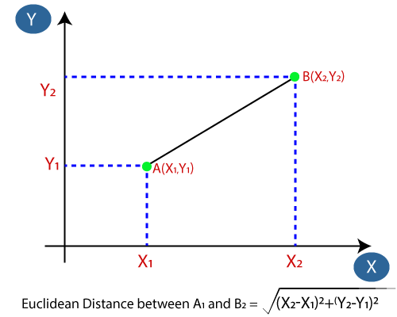

**Fig. 10.4:** Euclidean distance between the data points.

* 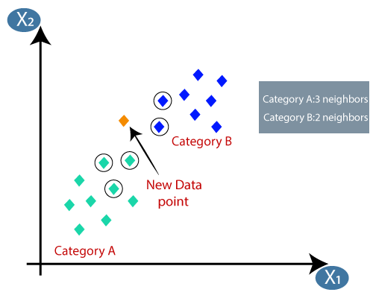By calculating the Euclidean distance we got the nearest neighbors, as three nearest neighbors in category A and two nearest neighbors in category B. Consider the below image:

**Fig. 10.5:** Calculating Nearest Neighbors **using** Euclidean distance .

* As we can see the 3 nearest neighbors are from category A, hence this new data point must belong to category A.

## How to select the value of K in the K-NN Algorithm?

## Below are some points to remember while selecting the value of K in the K-NN algorithm:

* There is no particular way to determine the best value for "K", so we need to try some values to find the best out of them. The most preferred value for K is 5.
* A very low value for K such as K=1 or K=2, can be noisy and lead to the effects of outliers in the model.
* Large values for K are good, but it may find some difficulties.

## Advantages of KNN Algorithm:

* It is simple to implement.
* It is robust to the noisy training data
* It can be more effective if the training data is large.

## Disadvantages of KNN Algorithm:

* Always needs to determine the value of K which may be complex some time.
* The computation cost is high because of calculating the distance between the data points for all the training samples

**CHAPTER-11**

**PROJECT-**

**Problem:- To Predict the House Price of Boston Housing Data.**

**Sources:**

(a) Origin: This dataset was taken from the StatLib library which is maintained at Carnegie Mellon University.

(b) Creator: Harrison, D. and Rubinfeld, D.L. 'Hedonic prices and the demand for clean air', J. Environ. Economics & Management, vol.5, 81-102, 1978.

(c) Date: July 7, 1993

**3. Past Usage:**

**-** Used in Belsley, Kuh & Welsch, 'Regression diagnostics ...', Wiley, 1980. N.B. Various transformations are used in the table on pages 244-261.

- Quinlan,R. (1993). Combining Instance-Based and Model-Based Learning. In Proceedings on the Tenth International Conference of Machine Learning, 236-243, University of Massachusetts, Amherst. Morgan Kaufmann.

**4. Relevant Information:** Concerns housing values in suburbs of Boston.

**5. Number of Instances:** 506

**6. Number of Attributes:** 13 continuous attributes (including "class" attribute "MEDV"), 1 binary-valued attribute.

**7. Attribute Information:**

1. CRIM per capita crime rate by town

2. ZN proportion of residential land zoned for lots over 25,000 sq.ft.

3. INDUS proportion of non-retail business acres per town

4. CHAS Charles River dummy variable (= 1 if tract bounds river; 0 otherwise)

5. NOX nitric oxides concentration (parts per 10 million)

6. RM average number of rooms per dwelling

7. AGE proportion of owner-occupied units built prior to 1940

8. DIS weighted distances to five Boston employment centres

9. RAD index of accessibility to radial highways

10. TAX full-value property-tax rate per $10,000

11. PTRATIO pupil-teacher ratio by town

12. B 1000(Bk - 0.63)^2 where Bk is the proportion of blacks by town

13. LSTAT % lower status of the population

14. MEDV Median value of owner-occupied homes in $1000's

**PROJECT CODE**

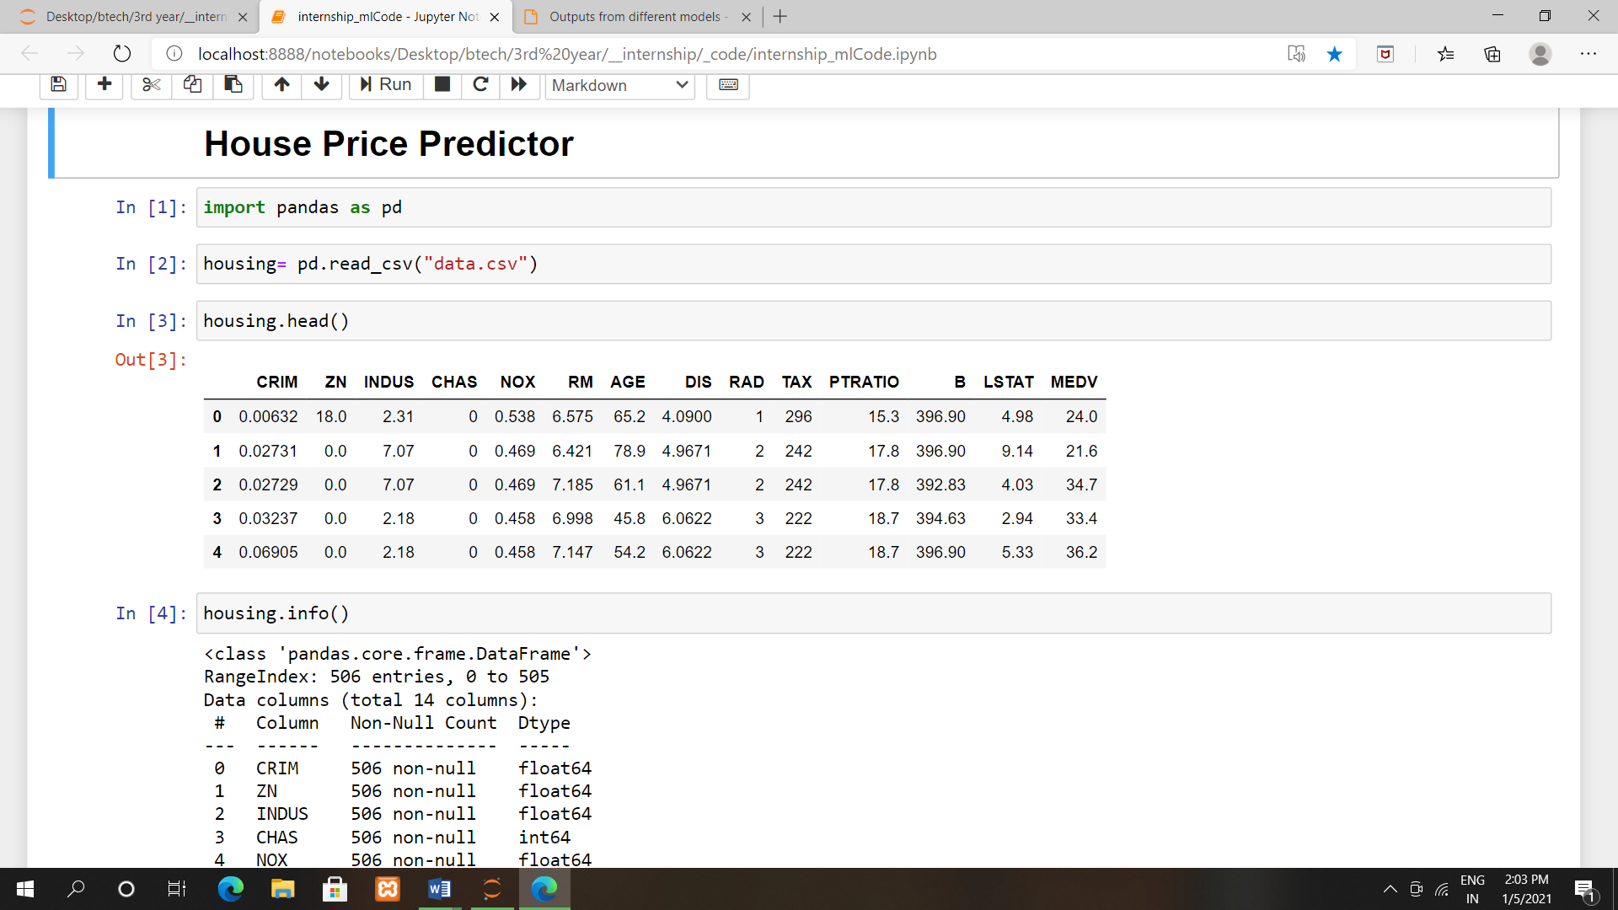

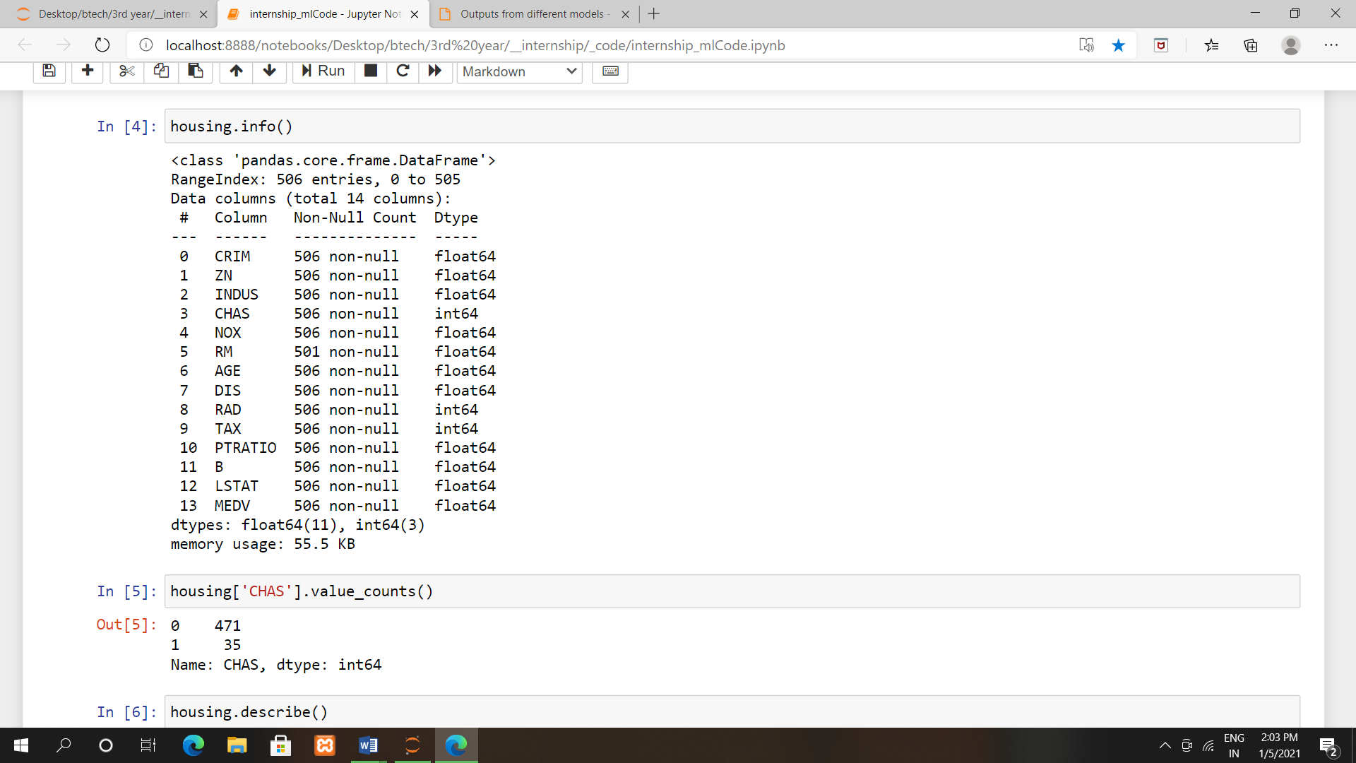

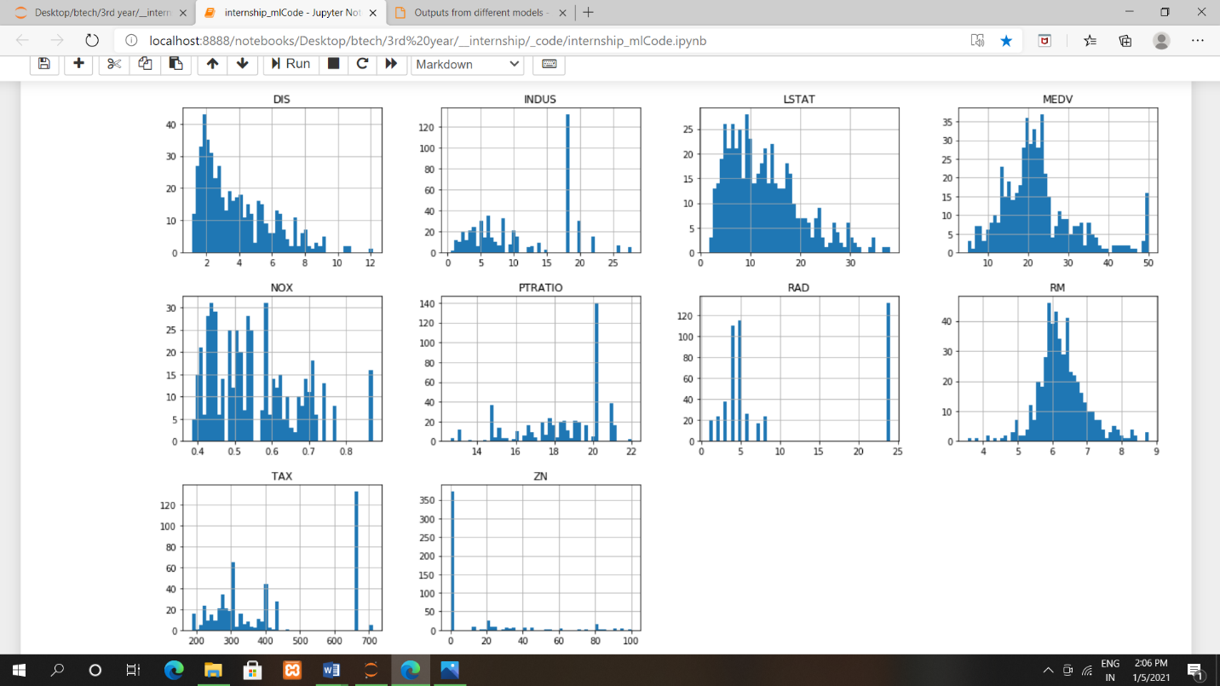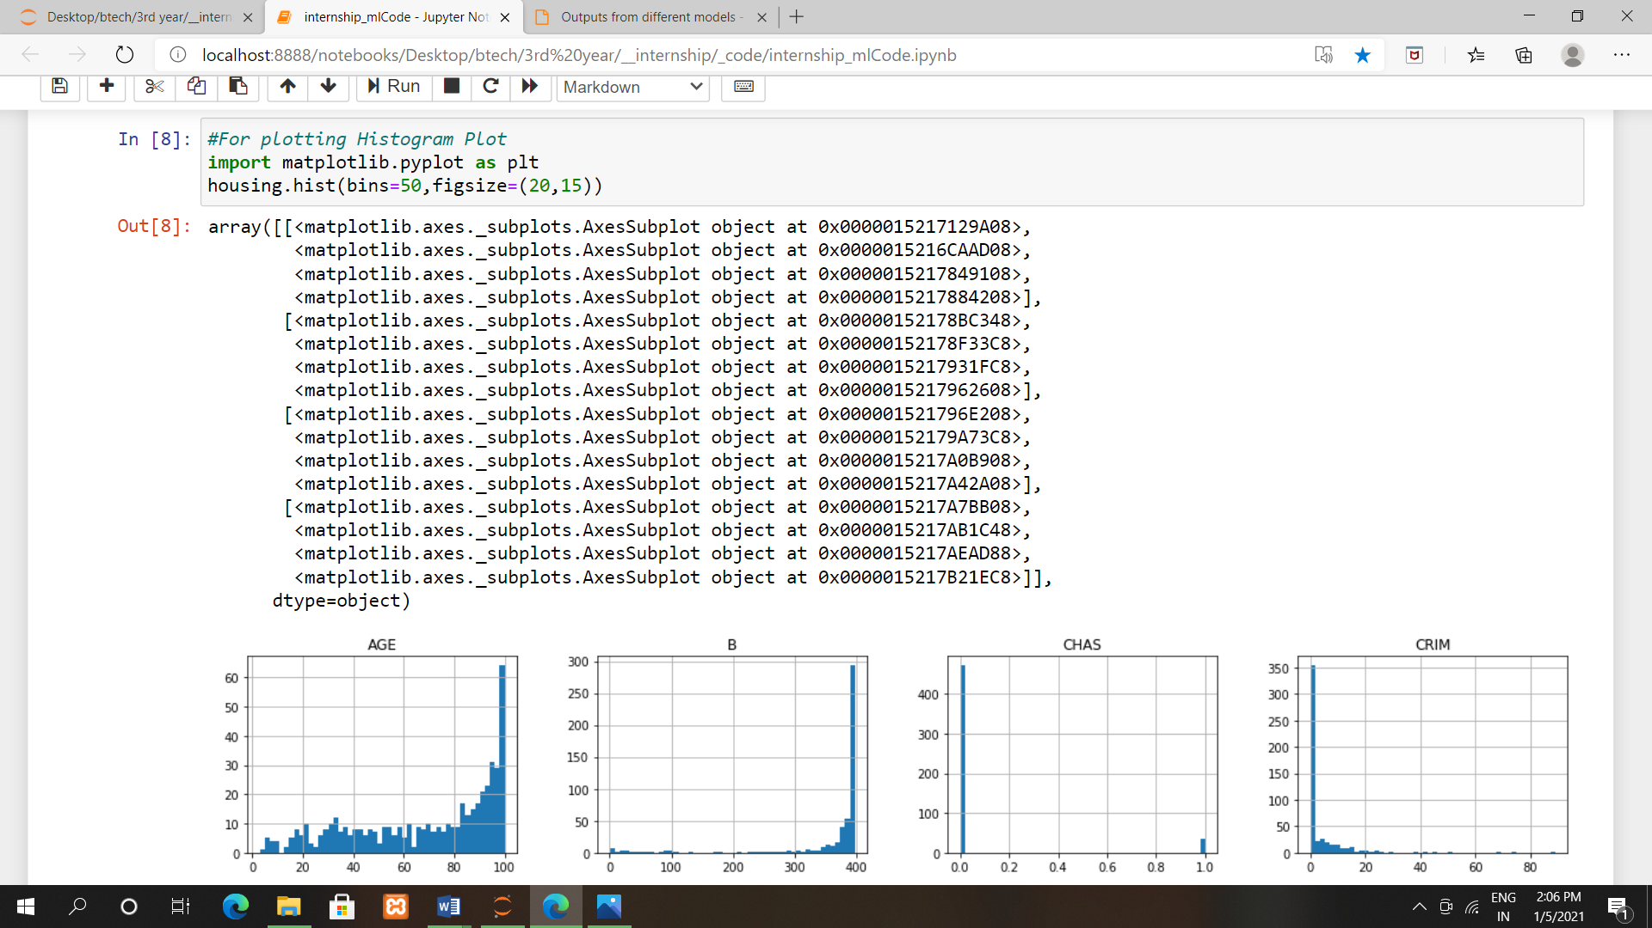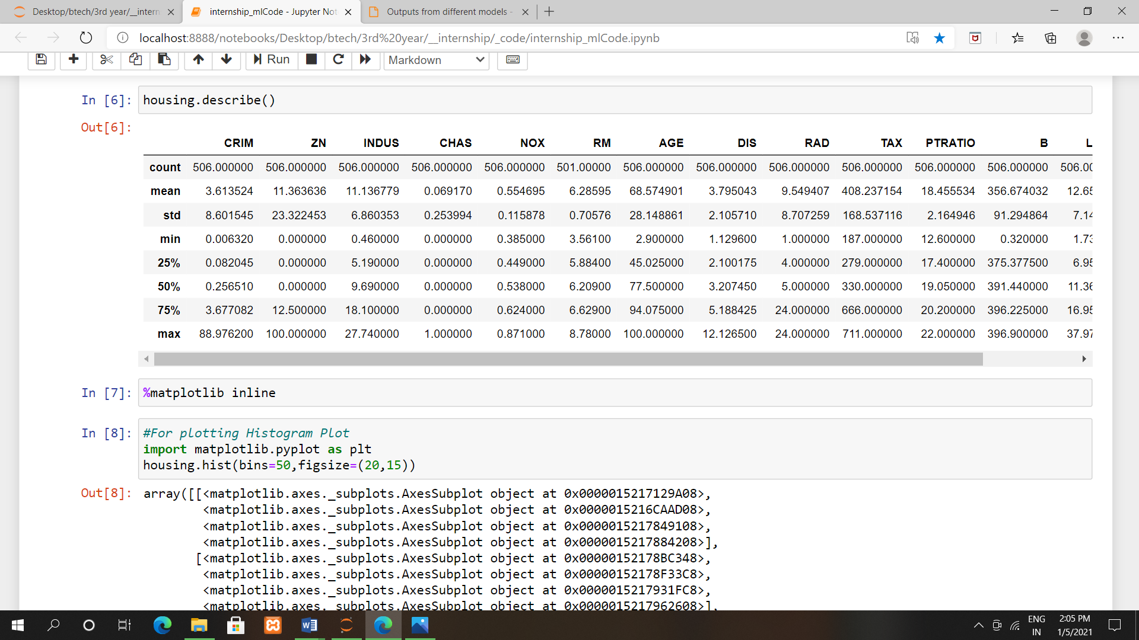

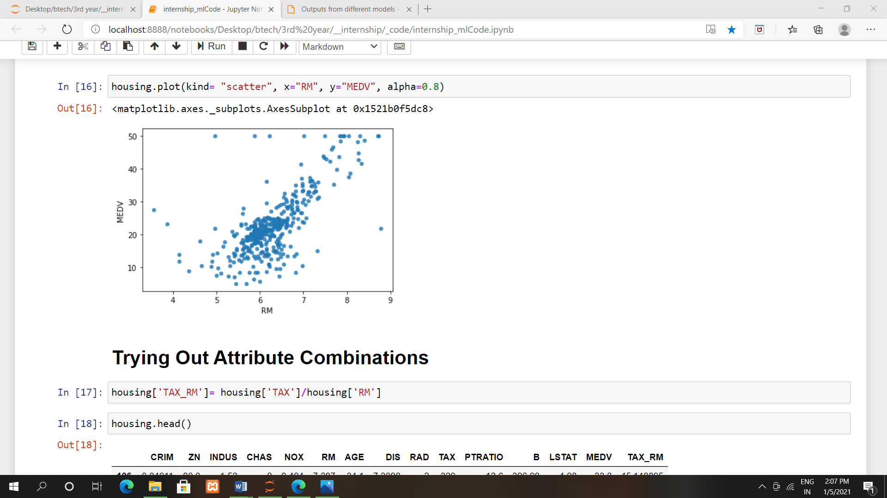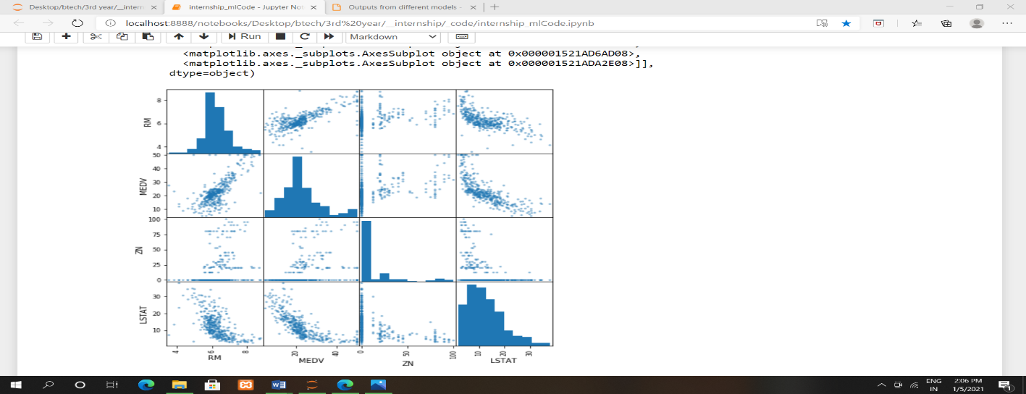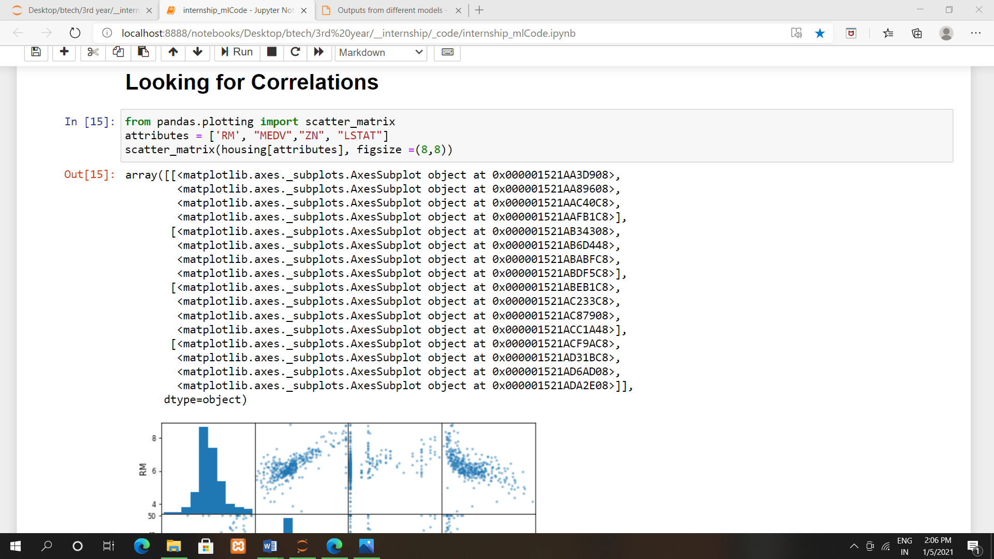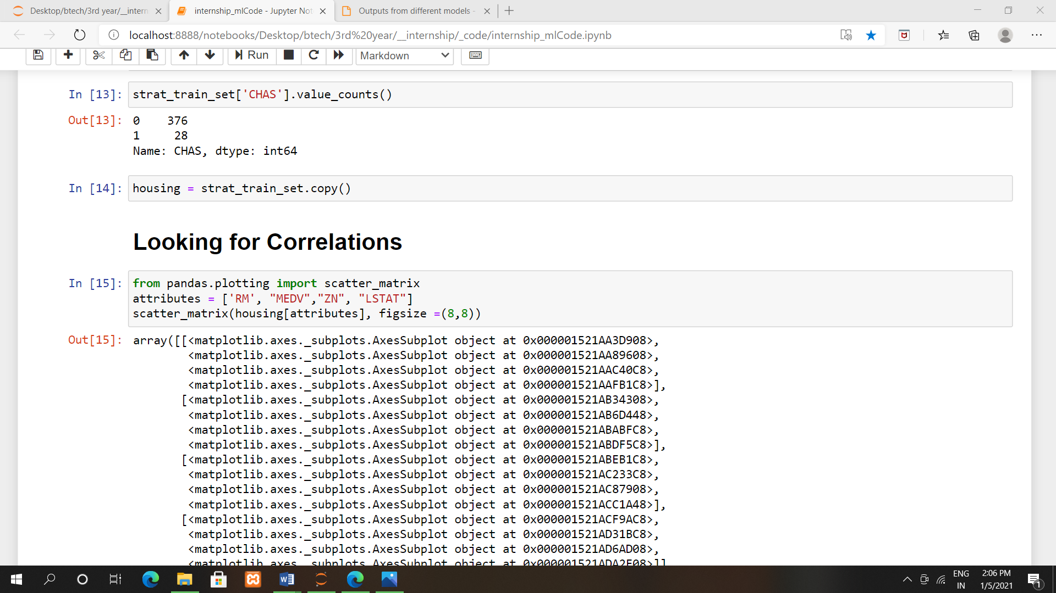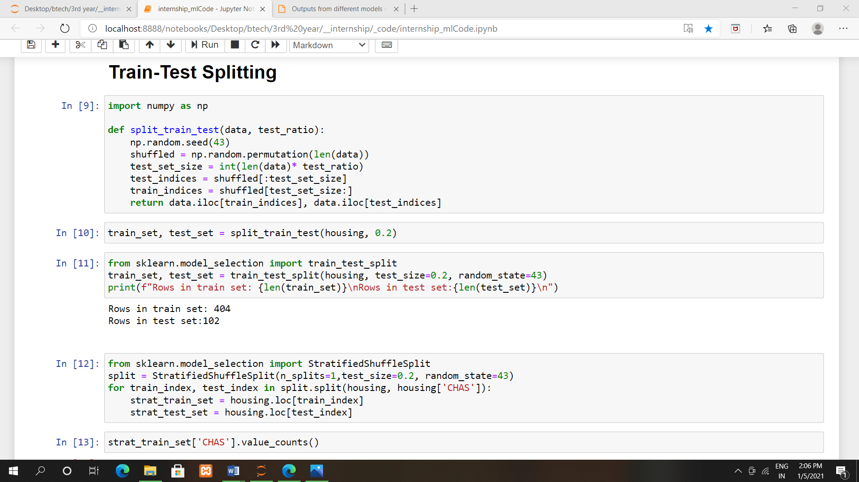

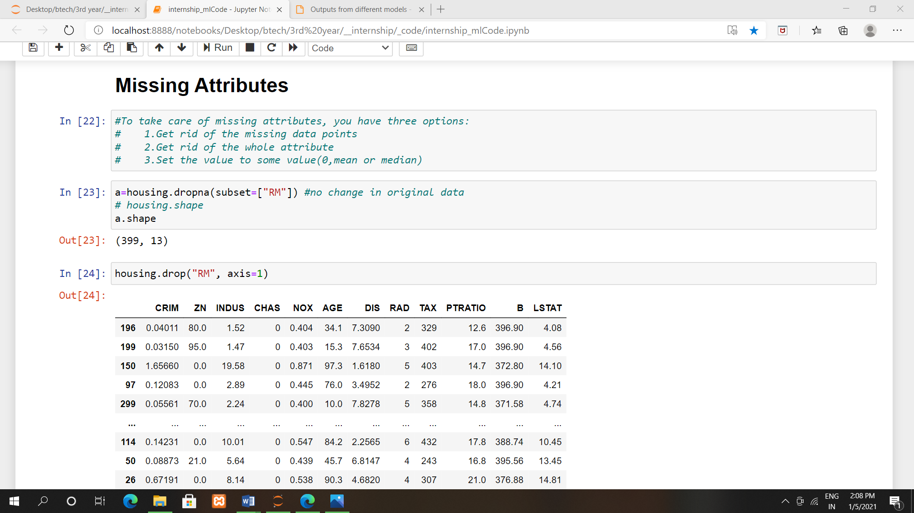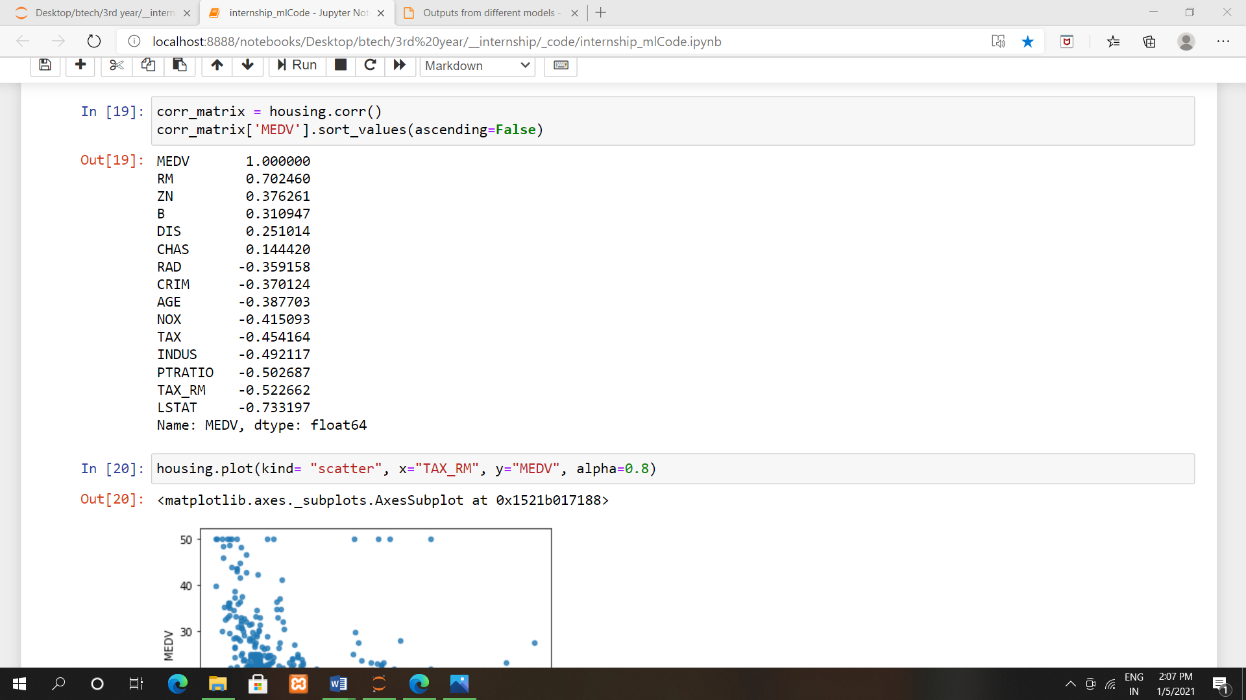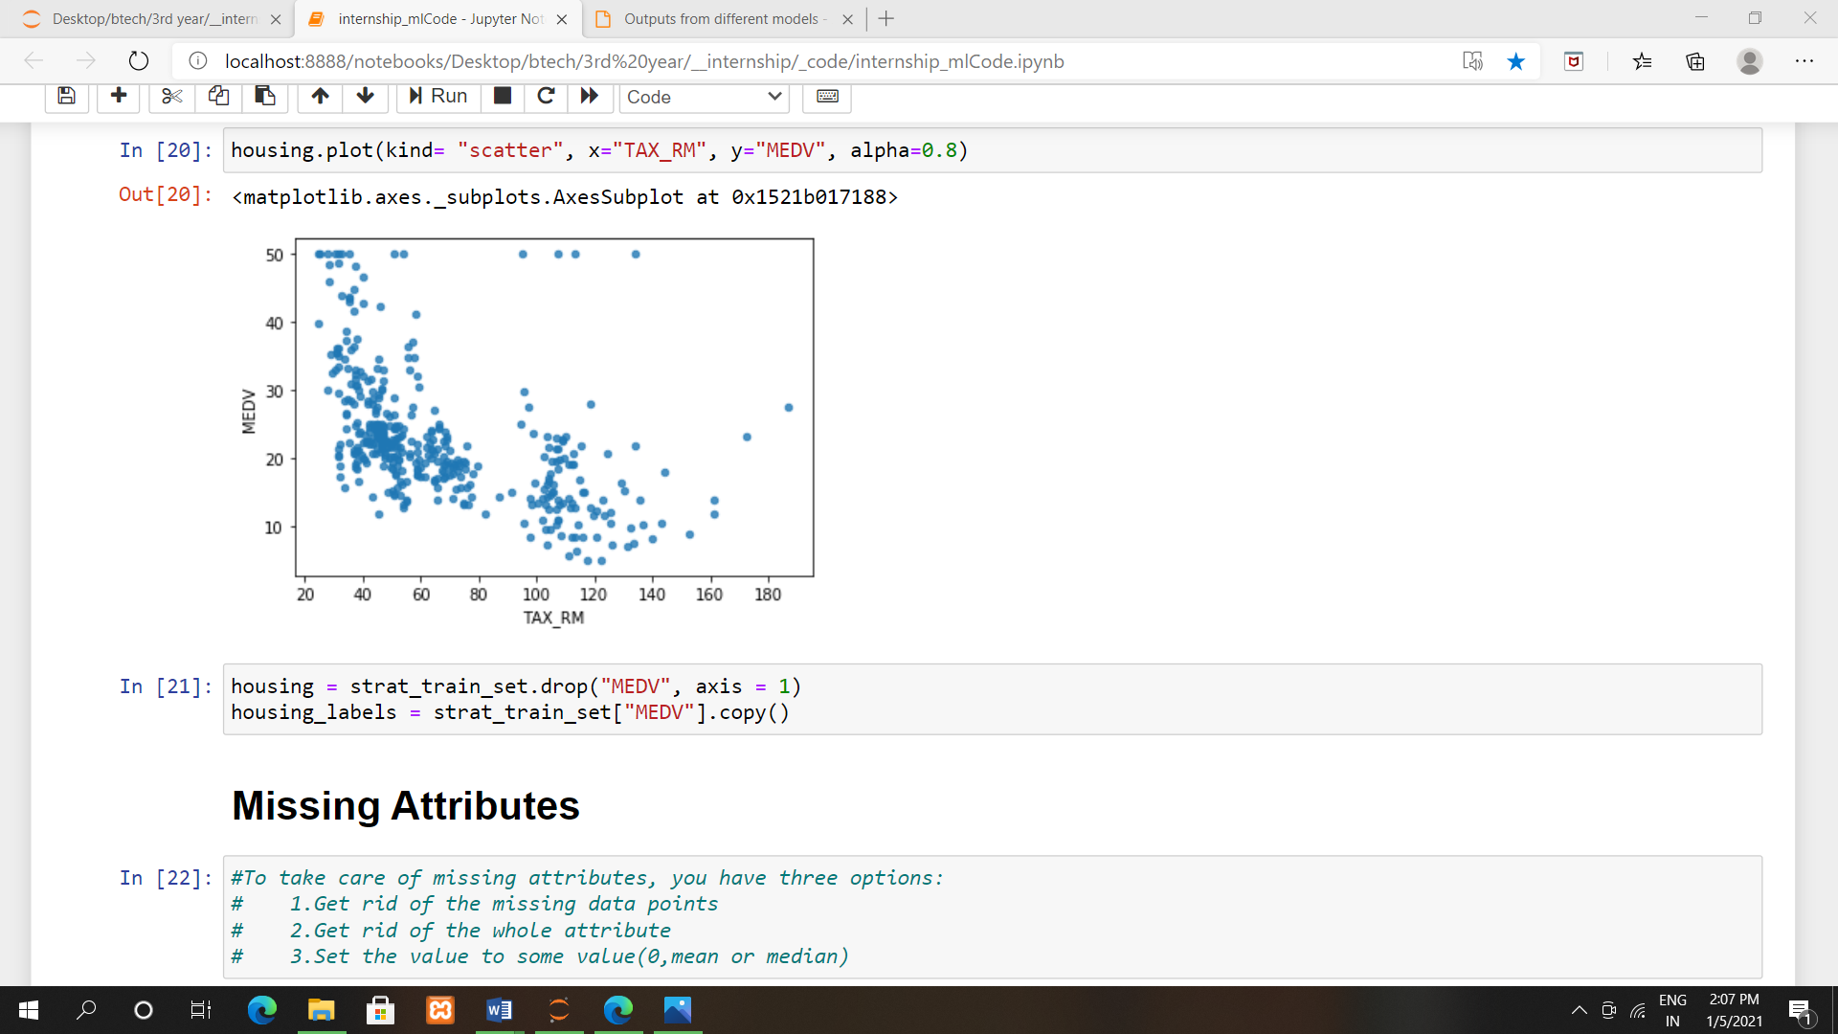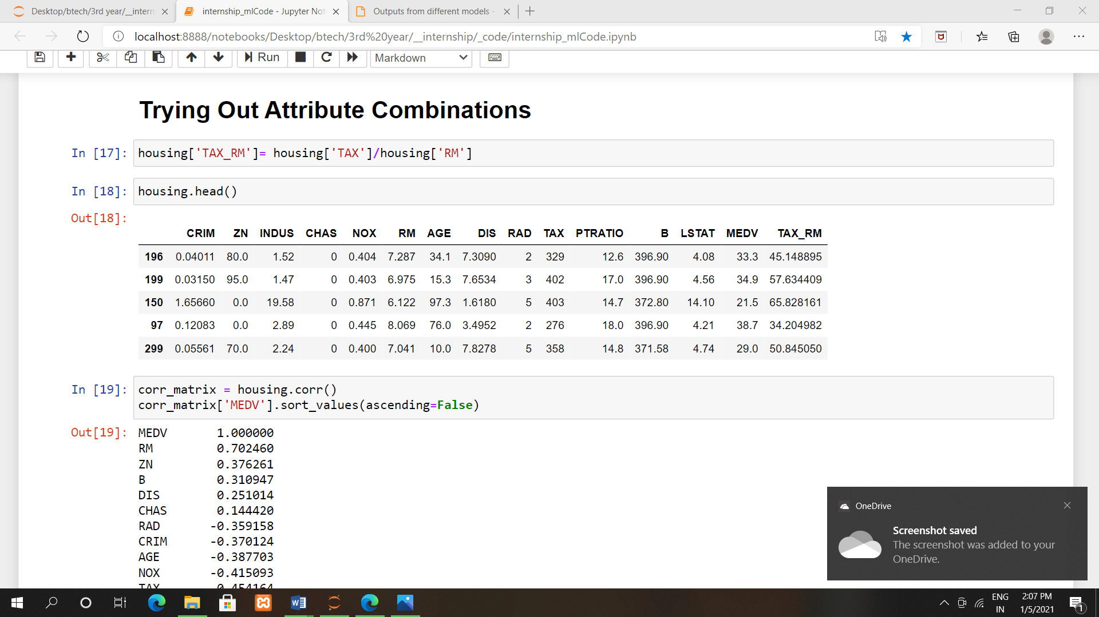

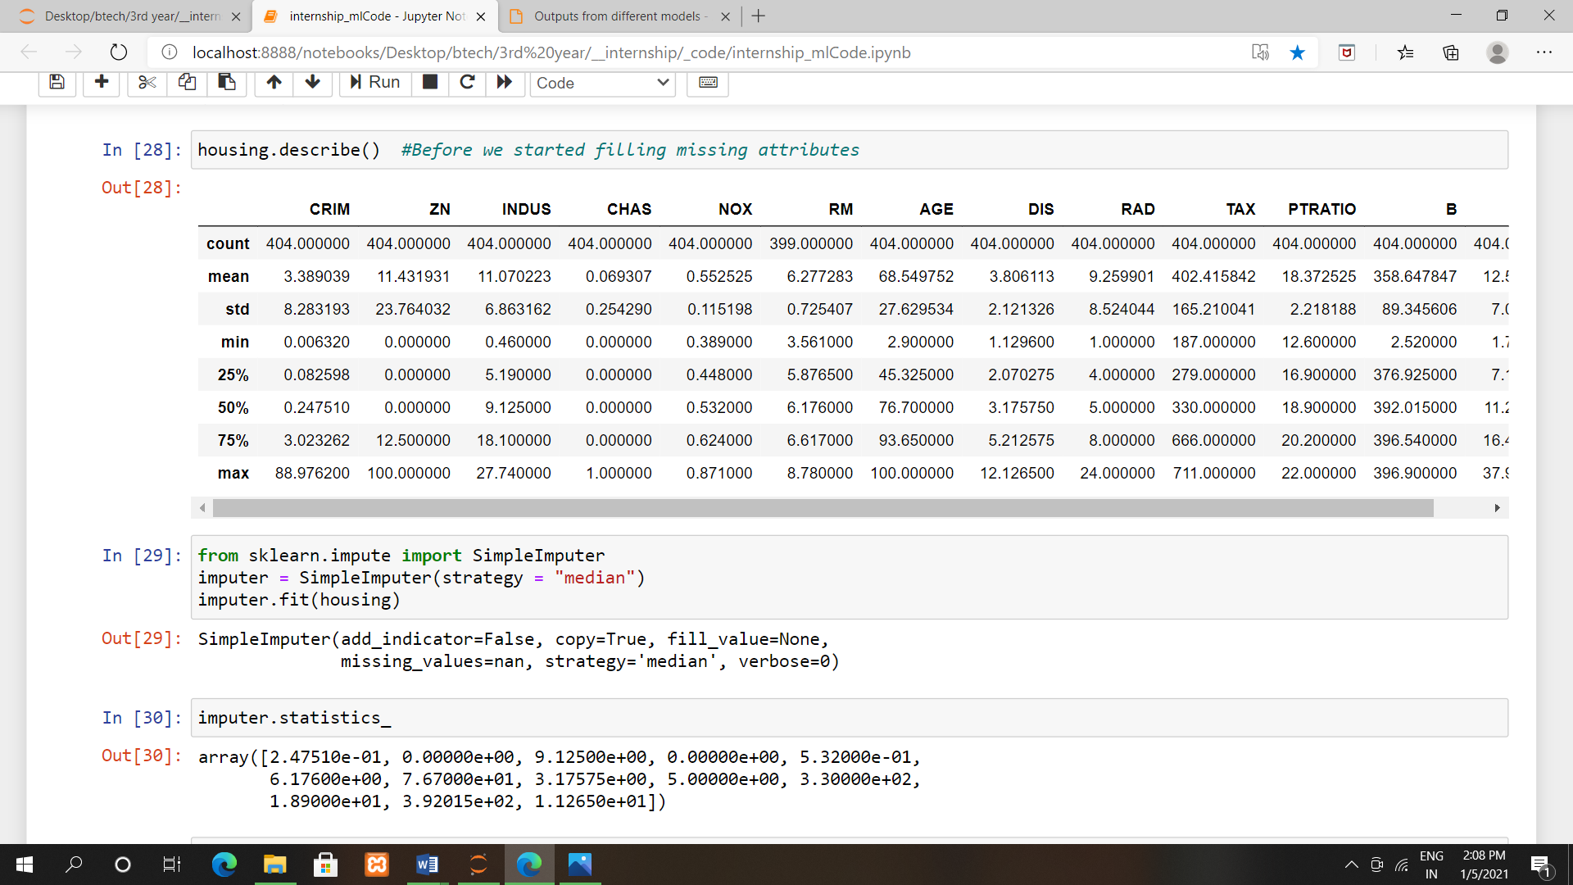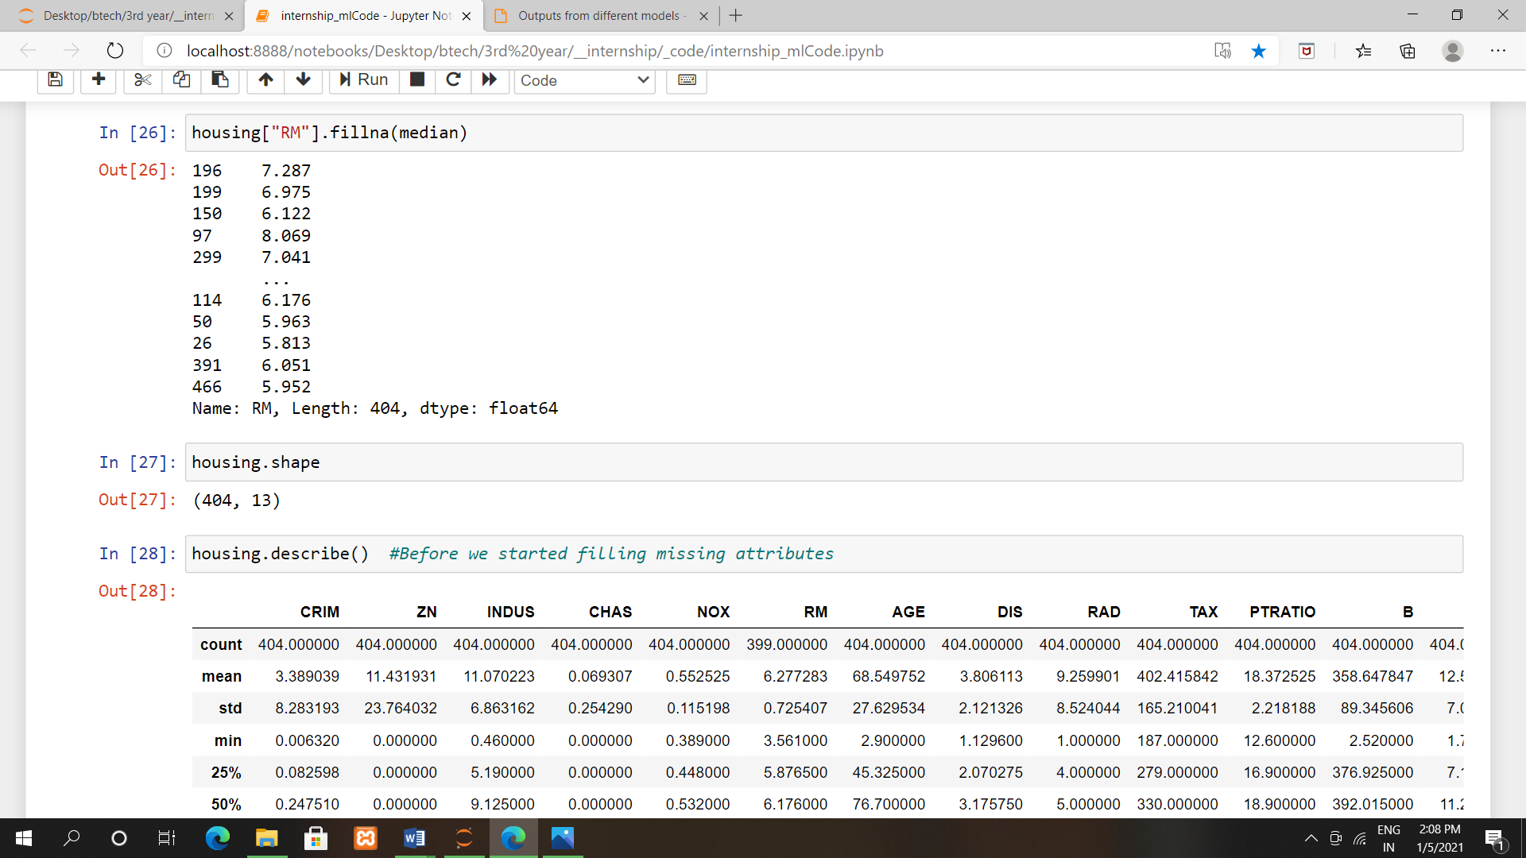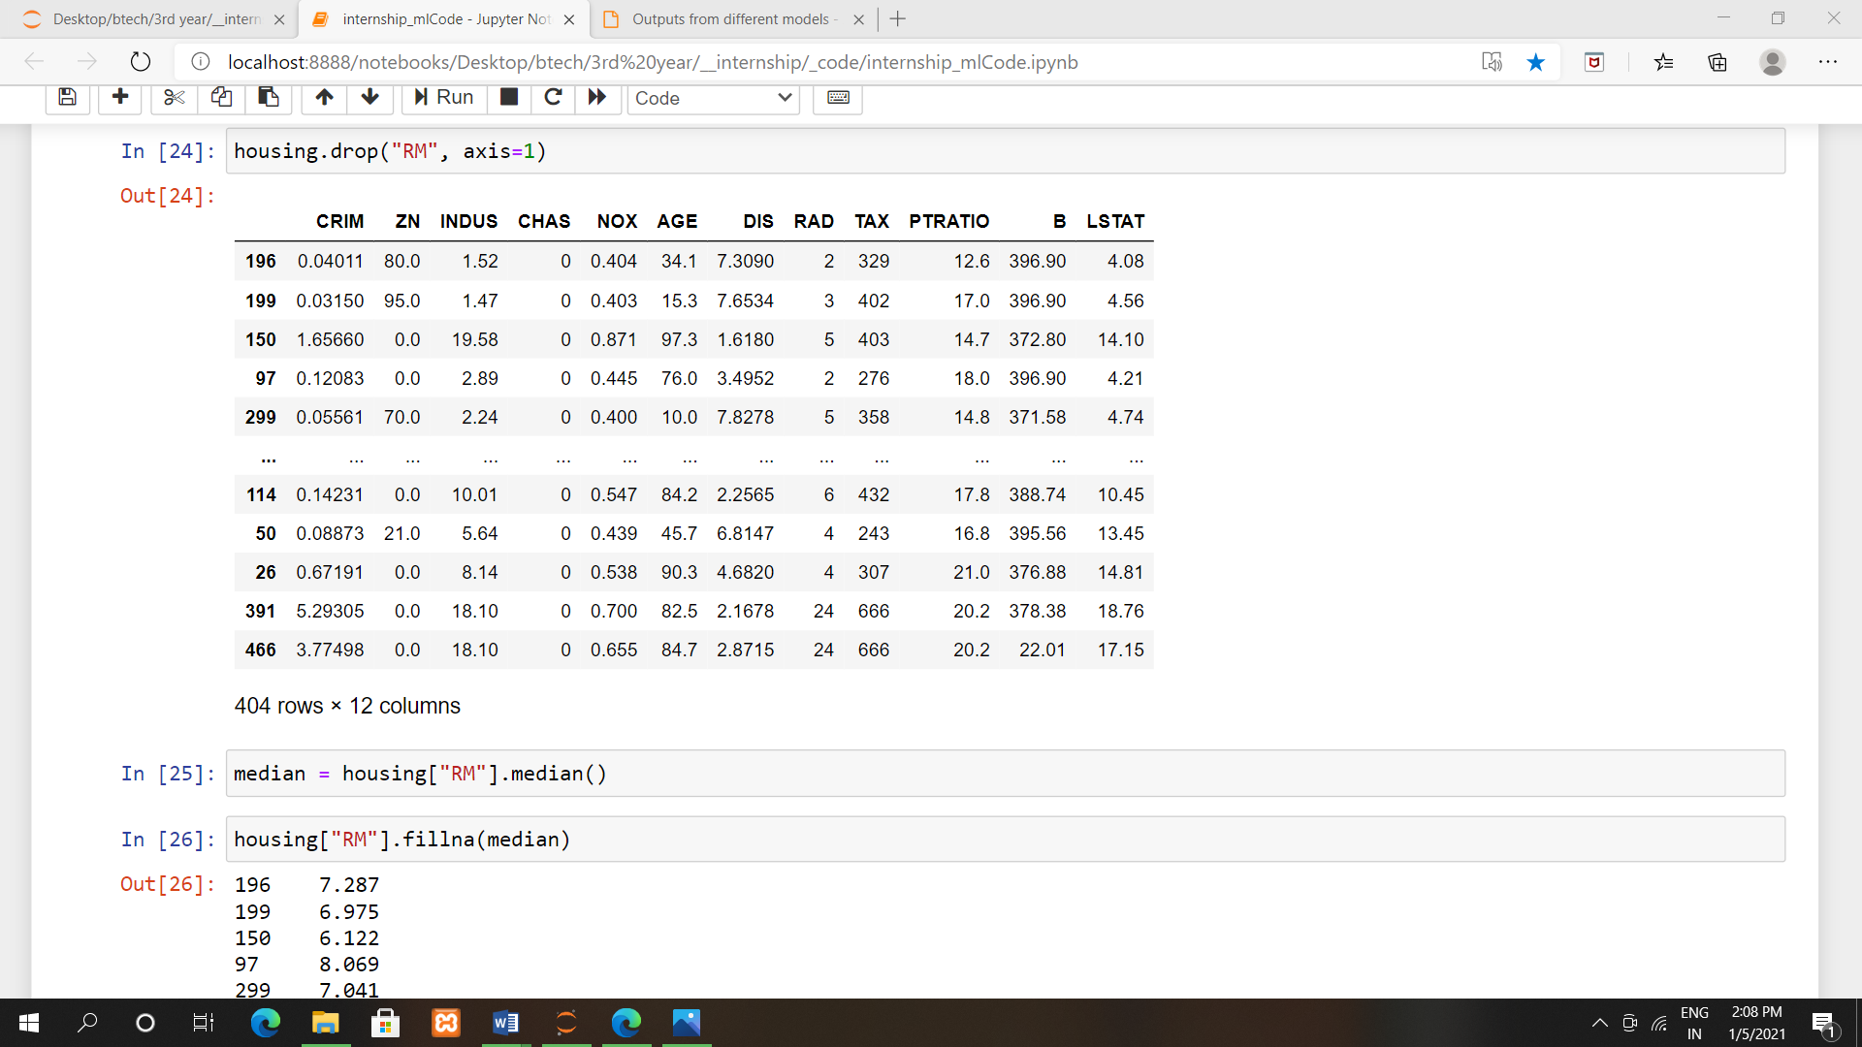

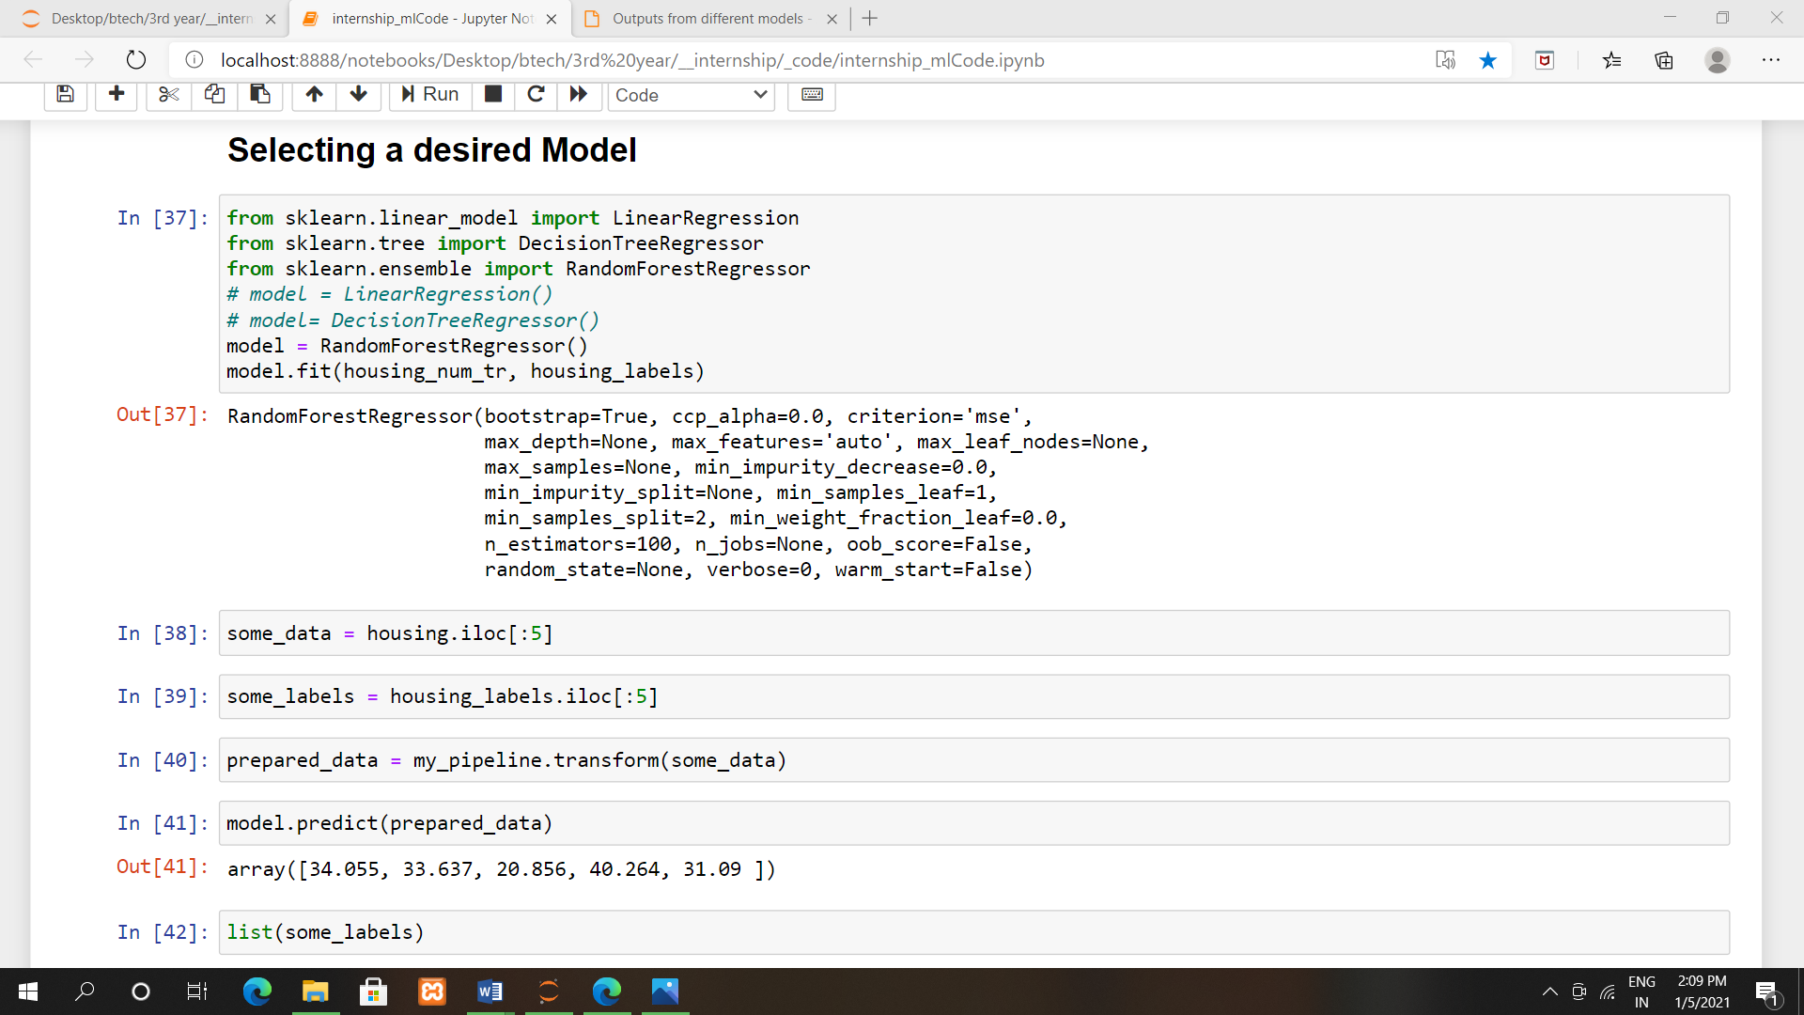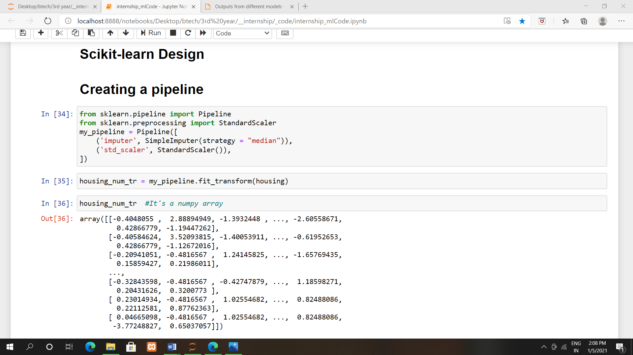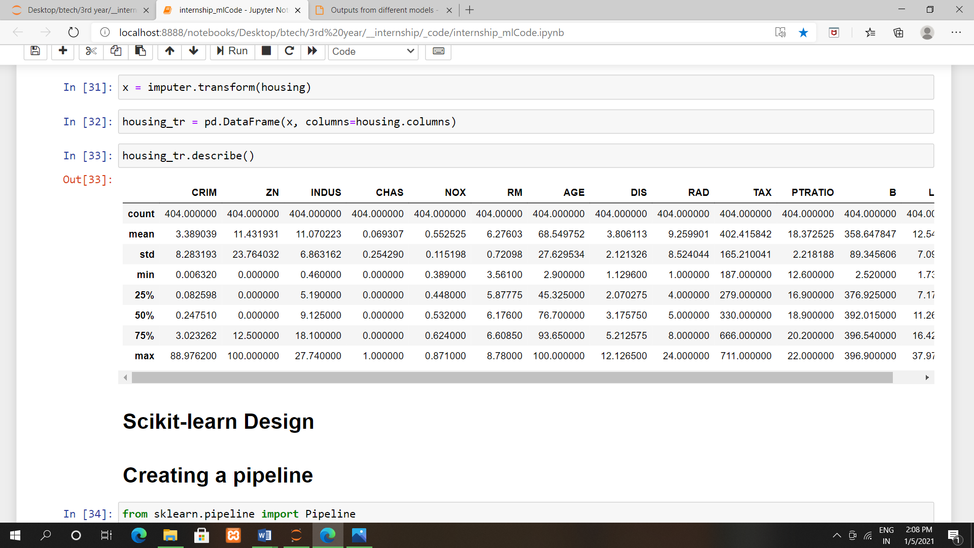

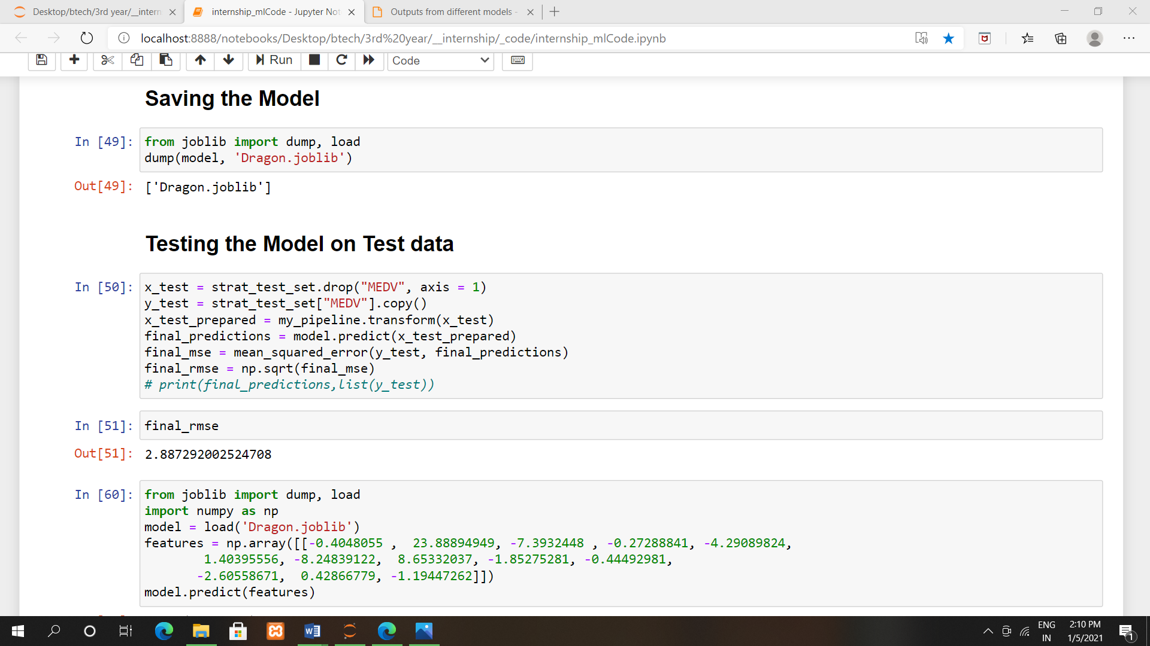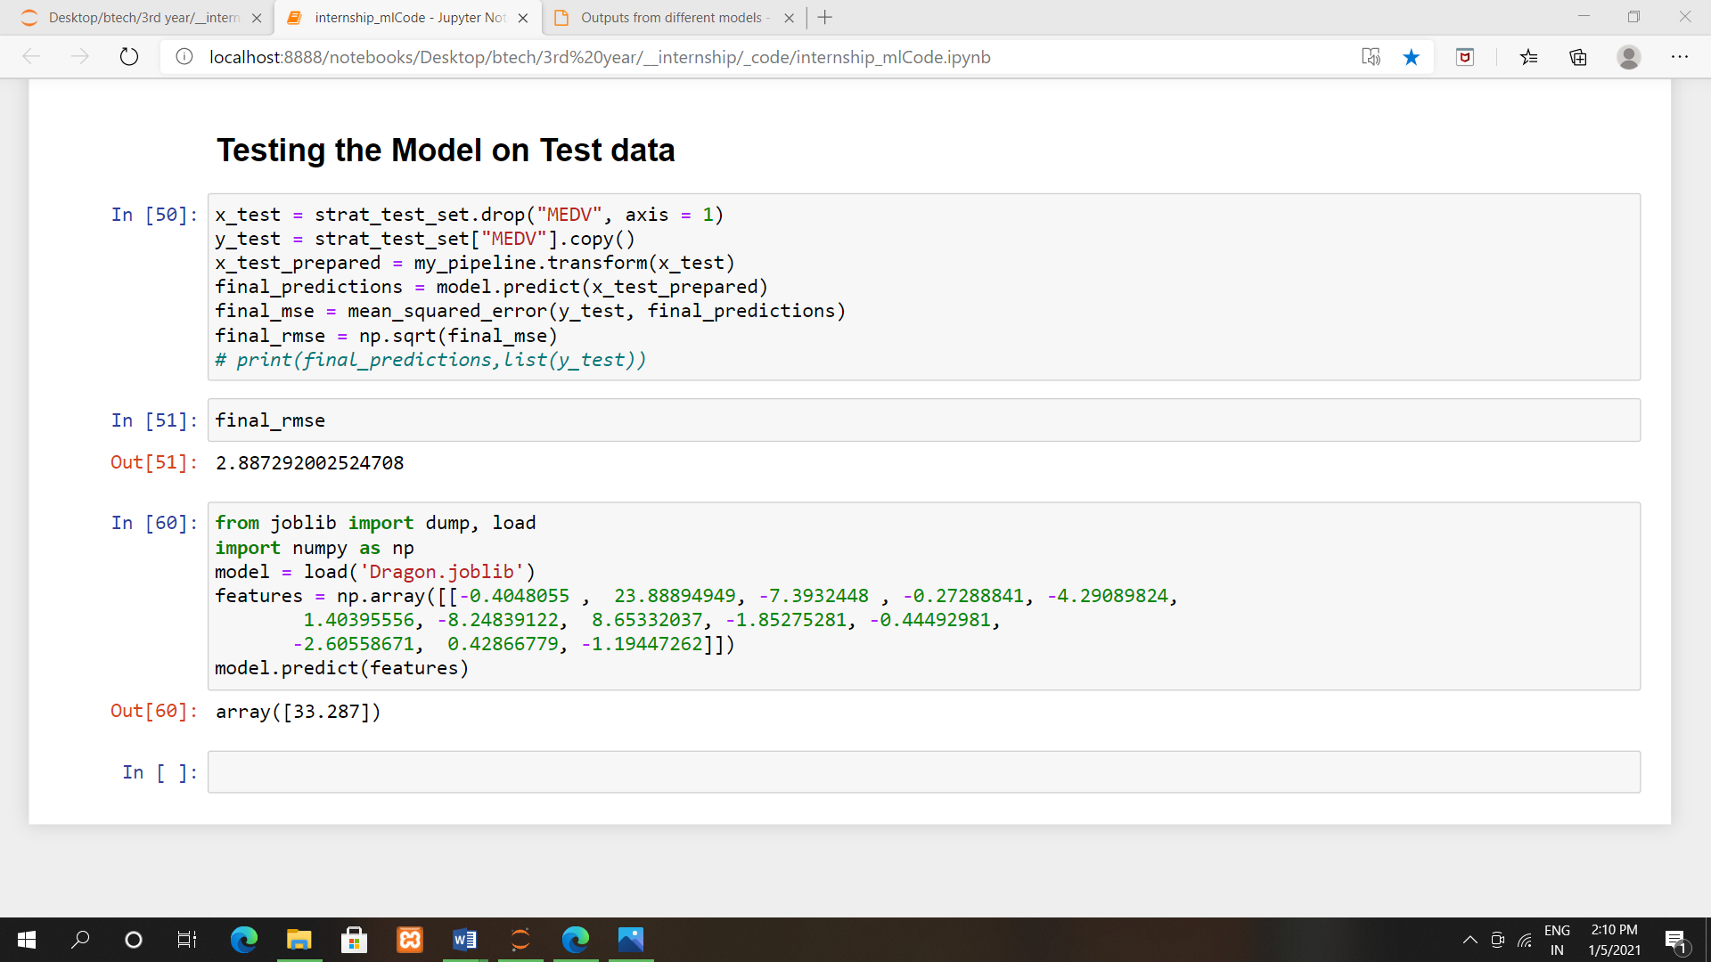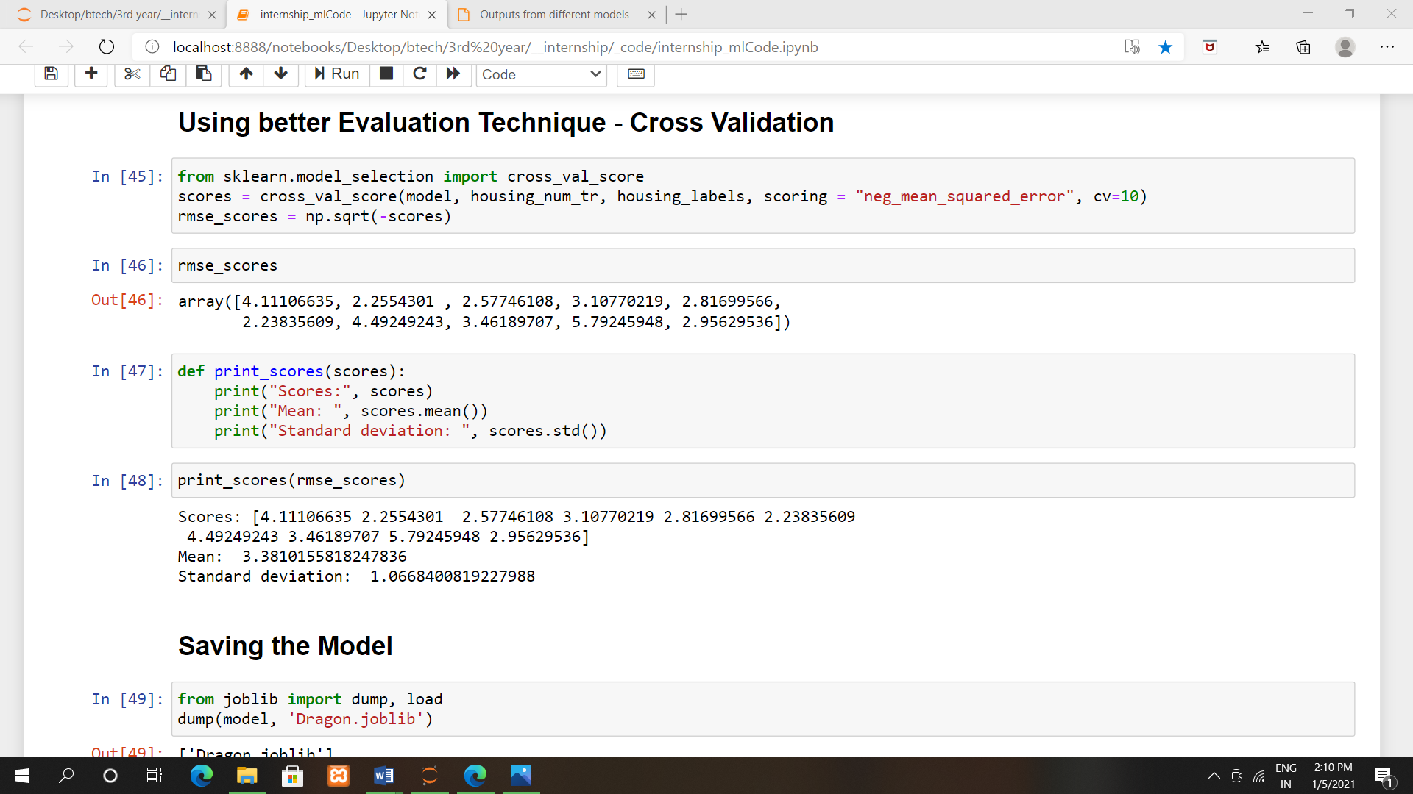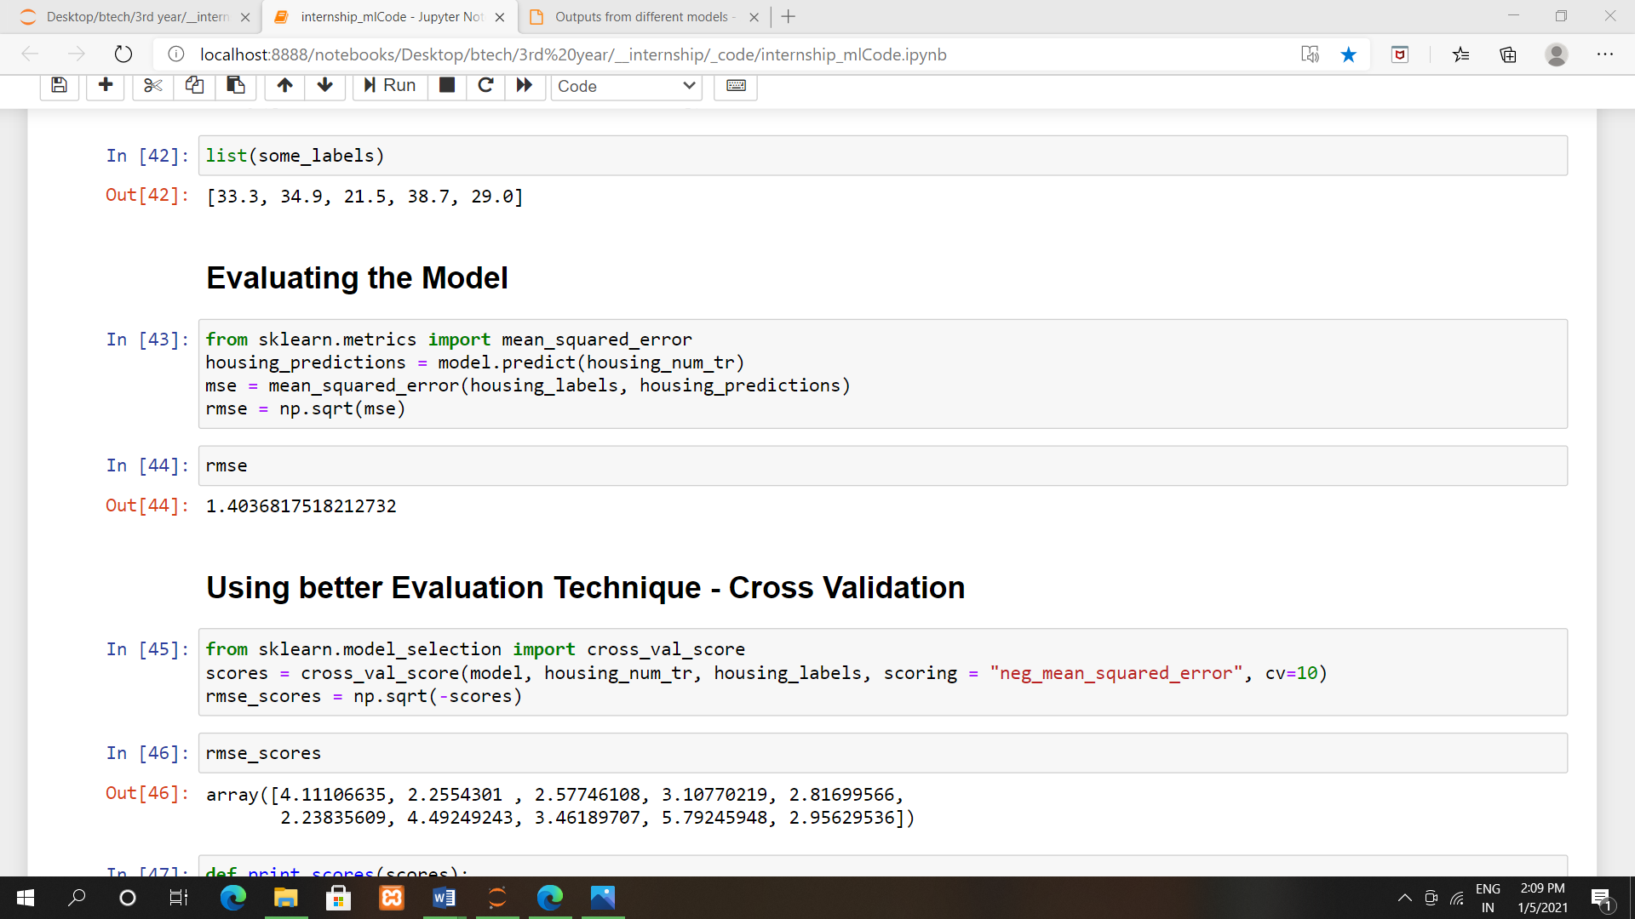

**REFERENCES:-**

Code of My Project on Google Drive :

[*https://drive.google.com/drive/folders/19JPtSDKSKwbWPjSL8nX2XcVXPl4cedcB?usp=sharing*](https://drive.google.com/drive/folders/19JPtSDKSKwbWPjSL8nX2XcVXPl4cedcB?usp=sharing)

P.P.T Link on Google Drive :

[*https://drive.google.com/file/d/1clz71WMt8wsMytlnCOOIIxwYepE9yDxs/view?usp=sharing*](https://drive.google.com/file/d/1clz71WMt8wsMytlnCOOIIxwYepE9yDxs/view?usp=sharing)

For more knowedge:

1. [*https://drive.google.com/drive/folders/19JPtSDKSKwbWPjSL8nX2XcVXPl4cedcB?usp=sharing*](https://drive.google.com/drive/folders/19JPtSDKSKwbWPjSL8nX2XcVXPl4cedcB?usp=sharing)
2. [*Machine Learning Tutorial - Tutorialspoint*](https://www.tutorialspoint.com/machine_learning/index.htm)
3. [*Start Here with Machine Learning (machinelearningmastery.com)*](https://machinelearningmastery.com/start-here/#algorithms)
4. [*Machine Learning Glossary — ML Glossary documentation (ml-cheatsheet.readthedocs.io)*](https://ml-cheatsheet.readthedocs.io/en/latest/)
5. [*Machine Learning Algorithm Cheat Sheet - designer - Azure Machine Learning | Microsoft Docs*](https://docs.microsoft.com/en-us/azure/machine-learning/algorithm-cheat-sheet)
6. [*ML Cheatsheet Documentation (readthedocs.org)*](https://readthedocs.org/projects/ml-cheatsheet/downloads/pdf/latest/)